 | Министерство науки и высшего образования Российской Федерации  Калужский филиал  федерального государственного бюджетного  образовательного учреждения высшего образования  «Московский государственный технический университет имени Н.Э. Баумана (национальный исследовательский университет)»  (КФ МГТУ им. Н.Э. Баумана)
ФАКУЛЬТЕТ _ИУК «Информатика и управление»______________
КАФЕДРА __ИУК4 «Программное обеспечение ЭВМ, информационные технологии»

ЛАБОРАТОРНАЯ РАБОТА №4

«Использование БД а Andoid приложениях»

ДИСЦИПЛИНА: «Разработка мобильного ПО»

Выполнил: студент гр. ИУК4-52Б |  | _________________ (______Губин Е.В._____)  (Подпись) (Ф.И.О.)
Проверил: |  | _________________ (_____Прудяк П.Н._____)  (Подпись) (Ф.И.О.)
Дата сдачи (защиты):
Результаты сдачи (защиты):
- Балльная оценка:
- Оценка:
Калуга, 2024 г.

Цель: формирование практических навыков разработки приложений с использованием СУБД SQLite, списков и файлов при разработке Android-приложений с несколькими Activity.

Задачи:
1. Научиться работать с СУБД SQLite.
2. Научиться сохранять результаты выполнения запросов к базе
данных в списки, файлы и LogCat.
3. Понять особенности реализации Android-приложений с
использованием списков и СУБД SQLite

Формулировка задания:

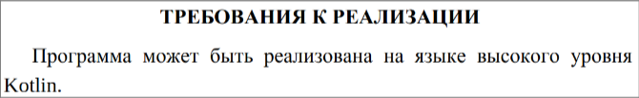
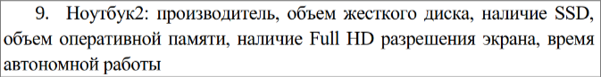
Листинг:

avg_group.kt:

package com.example.lw_4
import android.content.Intent
import android.os.Bundle
import android.widget.Button
import android.widget.ListView
import androidx.activity.enableEdgeToEdge
import androidx.appcompat.app.AppCompatActivity
import androidx.core.view.ViewCompat
import androidx.core.view.WindowInsetsCompat
class avg_group : AppCompatActivity() {
private lateinit var laptops: MutableList<Laptop>
private lateinit var prop: String
override fun onCreate(savedInstanceState: Bundle?) {
super.onCreate(savedInstanceState)
enableEdgeToEdge()
setContentView(R.layout.activity_avg_group)
val prop = intent.getStringExtra("prop")
if (prop != null) {
this.prop = prop
}
this.laptops = intent.getParcelableArrayListExtra<Laptop>("laptops") as ArrayList<Laptop>
this.renderLaptopListViews()
val mainButton = findViewById<Button>(R.id.mainButton)
mainButton.setOnClickListener {
val intent = Intent(this, MainActivity::class.java)
startActivity(intent)
}
ViewCompat.setOnApplyWindowInsetsListener(findViewById(R.id.main)) { v, insets ->
val systemBars = insets.getInsets(WindowInsetsCompat.Type.systemBars())
v.setPadding(systemBars.left, systemBars.top, systemBars.right, systemBars.bottom)
insets
}
}
private fun renderLaptopListViews() {
val laptopsListViews = findViewById<ListView>(R.id.listView)
if (this.prop == "Производитель") {
val laptopsItems: MutableList<TableAVGSomeItem> = mutableListOf()
for (i in 0..this.laptops.size - 1) {
laptopsItems.add(
TableAVGSomeItem(
"Производитель",
this.laptops[i].manufacturerName,
this.laptops[i].HDDVolume,
this.laptops[i].RAMVolume,
this.laptops[i].screenTime
))
}
val adapter = TableAVGSomeAdapter(this, laptopsItems)
laptopsListViews.adapter = adapter
}
else if (this.prop == "Наличие SSD") {
val laptopsItems: MutableList<TableAVGSomeItem> = mutableListOf()
for (i in 0..this.laptops.size - 1) {
laptopsItems.add(
TableAVGSomeItem(
"Наличие SSD",
this.laptops[i].SSDPresent.toString(),
this.laptops[i].HDDVolume,
this.laptops[i].RAMVolume,
this.laptops[i].screenTime
))
}
val adapter = TableAVGSomeAdapter(this, laptopsItems)
laptopsListViews.adapter = adapter
}
else if (this.prop == "Наличие FULL HD") {
val laptopsItems: MutableList<TableAVGSomeItem> = mutableListOf()
for (i in 0..this.laptops.size - 1) {
laptopsItems.add(
TableAVGSomeItem(
"Наличие FULL HD",
this.laptops[i].isFHD.toString(),
this.laptops[i].HDDVolume,
this.laptops[i].RAMVolume,
this.laptops[i].screenTime
))
}
val adapter = TableAVGSomeAdapter(this, laptopsItems)
laptopsListViews.adapter = adapter
}
else {
val laptopsItems: MutableList<TableAVGItem> = mutableListOf()
for (i in 0..this.laptops.size - 1) {
laptopsItems.add(
TableAVGItem(
this.laptops[i].HDDVolume,
this.laptops[i].RAMVolume,
this.laptops[i].screenTime
)
)
}
val adapter = TableAVGAdapter(this, laptopsItems)
laptopsListViews.adapter = adapter
}
}
}

DBHelper.kt:

package com.example.lw_4
import android.content.ContentValues
import android.content.Context
import android.database.Cursor
import android.database.sqlite.SQLiteDatabase
import android.database.sqlite.SQLiteOpenHelper
import android.widget.Toast
class DBHelper(context: Context, factory: SQLiteDatabase.CursorFactory?) :
SQLiteOpenHelper(context, DATABASE_NAME, factory, DATABASE_VERSION) {
override fun onCreate(db: SQLiteDatabase) {
val query = ("CREATE TABLE " + TABLE_NAME + " ("
+ ID_COL + " INTEGER PRIMARY KEY, " +
MANUFACTURE_NAME_COL + " VARCHAR(30) NOT NULL, " +
HDD_VOLUME_COL + " INTEGER NOT NULL, " +
SSD_PRESENT_COL + " BOOLEAN NOT NULL, " +
RAM_VOLUME_COL + " INTEGER NOT NULL, " +
IS_FHD_COL + " BOOLEAN NOT NULL, " +
SCREEN_TIME + " INTEGER NOT NULL);")
db.execSQL(query)
}
override fun onUpgrade(db: SQLiteDatabase, p1: Int, p2: Int) {
db.execSQL("DROP TABLE IF EXISTS " + TABLE_NAME)
onCreate(db)
}
fun getSortedList(prop: String, typeSort: String): MutableList<Laptop> {
var col = ""
if (prop == "Объём HDD") {
col = HDD_VOLUME_COL
}
else if (prop == "Объём RAM") {
col = RAM_VOLUME_COL
}
else {
col = SCREEN_TIME
}
val db = this.readableDatabase
val cursor = db.rawQuery("SELECT * FROM $TABLE_NAME ORDER BY ${col} $typeSort", null)
if (!cursor.moveToFirst()) {
cursor.close()
return mutableListOf()
}
val laptops: MutableList<Laptop> = mutableListOf()
var ID = 0
var manufacturerName = ""
var HDDVolume = 0
var SSDPresent = 0
var RAMVolume = 0
var isFHD = 0
var screenTime = 0
do {
var columnIndex = cursor.getColumnIndex(DBHelper.ID_COL)
ID = cursor.getInt(columnIndex)
columnIndex = cursor.getColumnIndex(DBHelper.MANUFACTURE_NAME_COL)
manufacturerName = cursor.getString(columnIndex)
columnIndex = cursor.getColumnIndex(DBHelper.HDD_VOLUME_COL)
HDDVolume = cursor.getInt(columnIndex)
columnIndex = cursor.getColumnIndex(DBHelper.SSD_PRESENT_COL)
SSDPresent = cursor.getInt(columnIndex)
columnIndex = cursor.getColumnIndex(DBHelper.RAM_VOLUME_COL)
RAMVolume = cursor.getInt(columnIndex)
columnIndex = cursor.getColumnIndex(DBHelper.IS_FHD_COL)
isFHD = cursor.getInt(columnIndex)
columnIndex = cursor.getColumnIndex(DBHelper.SCREEN_TIME)
screenTime = cursor.getInt(columnIndex)
laptops.add(Laptop(
ID,
manufacturerName,
HDDVolume,
if (SSDPresent == 1) true else false,
RAMVolume,
if (isFHD == 1) true else false, screenTime)
)
} while (cursor.moveToNext())
cursor.close()
return laptops
}
fun addLaptop(
manufacturerName: String,
HDDVolume: Int, SSDPresent: Boolean,
RAMVolume: Int,
isFHD: Boolean,
screenTime: Int
){
val values = ContentValues()
values.put(MANUFACTURE_NAME_COL, manufacturerName)
values.put(HDD_VOLUME_COL, HDDVolume)
values.put(SSD_PRESENT_COL, SSDPresent)
values.put(RAM_VOLUME_COL, RAMVolume)
values.put(IS_FHD_COL, isFHD)
values.put(SCREEN_TIME, screenTime)
val db = this.writableDatabase
db.insert(TABLE_NAME, null, values)
db.close()
}
fun deleteLaptopById(id: Int) {
val db = this.writableDatabase
val whereClause = "id = ?"
val whereArgs = arrayOf(id.toString())
db.delete(TABLE_NAME, whereClause, whereArgs)
db.close()
}
fun getLaptops(): MutableList<Laptop> {
val db = this.readableDatabase
val cursor = db.rawQuery("SELECT * FROM " + TABLE_NAME, null)
if (!cursor.moveToFirst()) {
cursor.close()
return mutableListOf()
}
val laptops: MutableList<Laptop> = mutableListOf()
var ID = 0
var manufacturerName = ""
var HDDVolume = 0
var SSDPresent = 0
var RAMVolume = 0
var isFHD = 0
var screenTime = 0
do {
var columnIndex = cursor.getColumnIndex(DBHelper.ID_COL)
ID = cursor.getInt(columnIndex)
columnIndex = cursor.getColumnIndex(DBHelper.MANUFACTURE_NAME_COL)
manufacturerName = cursor.getString(columnIndex)
columnIndex = cursor.getColumnIndex(DBHelper.HDD_VOLUME_COL)
HDDVolume = cursor.getInt(columnIndex)
columnIndex = cursor.getColumnIndex(DBHelper.SSD_PRESENT_COL)
SSDPresent = cursor.getInt(columnIndex)
columnIndex = cursor.getColumnIndex(DBHelper.RAM_VOLUME_COL)
RAMVolume = cursor.getInt(columnIndex)
columnIndex = cursor.getColumnIndex(DBHelper.IS_FHD_COL)
isFHD = cursor.getInt(columnIndex)
columnIndex = cursor.getColumnIndex(DBHelper.SCREEN_TIME)
screenTime = cursor.getInt(columnIndex)
laptops.add(Laptop(
ID,
manufacturerName,
HDDVolume,
if (SSDPresent == 1) true else false,
RAMVolume,
if (isFHD == 1) true else false, screenTime)
)
} while (cursor.moveToNext())
cursor.close()
return laptops
}
fun getIDs(): List<Int> {
val db = this.readableDatabase
val idList = mutableListOf<Int>()
val cursor = db.rawQuery("SELECT id FROM " + TABLE_NAME, null)
val index = cursor.getColumnIndex(ID_COL)
if (cursor.moveToFirst()) {
do {
val ID = cursor.getInt(index)
idList.add(ID)
} while (cursor.moveToNext())
}
cursor.close()
db.close()
return idList
}
fun getSum(prop: String): Int {
var col = ""
if (prop == "Объём HDD") {
col = HDD_VOLUME_COL
}
else if (prop == "Объём RAM") {
col = RAM_VOLUME_COL
}
else {
col = SCREEN_TIME
}
val db = this.readableDatabase
var total = 0
val cursor = db.rawQuery("SELECT SUM(${col}) AS total FROM ${TABLE_NAME}", null)
if (cursor.moveToFirst()) {
val index = cursor.getColumnIndex("total")
total = cursor.getInt(index)
}
cursor.close()
return total
}
fun doubleGroup(option1: String, option2: String): MutableList<Laptop> {
var col1 = ""
if (option1 == "Производитель") {
col1 = MANUFACTURE_NAME_COL
}
else if (option1 == "Объём HDD") {
col1 = HDD_VOLUME_COL
}
else if (option1 == "Наличие SSD") {
col1 = SSD_PRESENT_COL
}
else if (option1 == "Объём RAM") {
col1 = RAM_VOLUME_COL
}
else if (option1 == "Наличие FULL HD") {
col1 = IS_FHD_COL
}
else {
col1 = SCREEN_TIME
}
var col2 = ""
if (option2 == "Производитель") {
col2 = MANUFACTURE_NAME_COL
}
else if (option2 == "Объём HDD") {
col2 = HDD_VOLUME_COL
}
else if (option2 == "Наличие SSD") {
col2 = SSD_PRESENT_COL
}
else if (option2 == "Объём RAM") {
col2 = RAM_VOLUME_COL
}
else if (option2 == "Наличие FULL HD") {
col2 = IS_FHD_COL
}
else {
col2 = SCREEN_TIME
}
val db = this.readableDatabase
val cursor = db.rawQuery("SELECT ${col1}, ${col2}, COUNT(*) as CountLines FROM ${TABLE_NAME} GROUP BY ${col1}, ${col2}", null)
if (!cursor.moveToFirst()) {
cursor.close()
return mutableListOf()
}
val laptops: MutableList<Laptop> = mutableListOf()
var columnIndex = 0
var laptop = Laptop()
do {
laptop = Laptop()
columnIndex = cursor.getColumnIndex(col1)
if (col1 == MANUFACTURE_NAME_COL) {
laptop.manufacturerName = cursor.getString(columnIndex)
}
else if (col1 == HDD_VOLUME_COL) {
laptop.HDDVolume = cursor.getInt(columnIndex)
}
else if (col1 == SSD_PRESENT_COL) {
val baf = cursor.getInt(columnIndex)
laptop.SSDPresent = if (baf == 1) true else false
}
else if (col1 == RAM_VOLUME_COL) {
laptop.RAMVolume = cursor.getInt(columnIndex)
}
else if (col1 == IS_FHD_COL) {
val baf = cursor.getInt(columnIndex)
laptop.isFHD = if (baf == 1) true else false
}
else {
laptop.screenTime = cursor.getInt(columnIndex)
}
columnIndex = cursor.getColumnIndex(col2)
if (col2 == MANUFACTURE_NAME_COL) {
laptop.manufacturerName = cursor.getString(columnIndex)
}
else if (col2 == HDD_VOLUME_COL) {
laptop.HDDVolume = cursor.getInt(columnIndex)
}
else if (col2 == SSD_PRESENT_COL) {
val baf = cursor.getInt(columnIndex)
laptop.SSDPresent = if (baf == 1) true else false
}
else if (col2 == RAM_VOLUME_COL) {
laptop.RAMVolume = cursor.getInt(columnIndex)
}
else if (col2 == IS_FHD_COL) {
val baf = cursor.getInt(columnIndex)
laptop.isFHD = if (baf == 1) true else false
}
else {
laptop.screenTime = cursor.getInt(columnIndex)
}
columnIndex = cursor.getColumnIndex("CountLines")
laptop.count = cursor.getInt(columnIndex)
laptops.add(laptop)
} while (cursor.moveToNext())
cursor.close()
return laptops
}
fun groupBy(prop: String): MutableList<Laptop> {
var col = ""
val cols: MutableList<String> = mutableListOf(
HDD_VOLUME_COL,
RAM_VOLUME_COL,
SCREEN_TIME
)
if (prop == "Производитель") {
col = MANUFACTURE_NAME_COL
}
else if (prop == "Объём HDD") {
col = HDD_VOLUME_COL
}
else if (prop == "Наличие SSD") {
col = SSD_PRESENT_COL
}
else if (prop == "Объём RAM") {
col = RAM_VOLUME_COL
}
else if (prop == "Наличие FULL HD") {
col = IS_FHD_COL
}
else {
col = SCREEN_TIME
}
val db = this.readableDatabase
val cursor: Cursor
if (cols.contains(col)) {
cursor = db.rawQuery(
"SELECT " +
"AVG(${cols[0]}) as ${cols[0]}, " +
"AVG(${cols[1]}) as ${cols[1]}, " +
"AVG(${cols[2]}) as ${cols[2]} " +
"FROM $TABLE_NAME " +
"GROUP BY $col",
null)
}
else {
cursor = db.rawQuery(
"SELECT " +
"$col, " +
"AVG(${cols[0]}) as ${cols[0]}, " +
"AVG(${cols[1]}) as ${cols[1]}, " +
"AVG(${cols[2]}) as ${cols[2]} " +
"FROM $TABLE_NAME " +
"GROUP BY $col",
null)
}
if (!cursor.moveToFirst()) {
cursor.close()
return mutableListOf()
}
val laptops: MutableList<Laptop> = mutableListOf()
var HDDVolume = 0
var RAMVolume = 0
var screenTime = 0
var laptop: Laptop
var columnIndex = 0
if (cols.contains(col)) {
do {
columnIndex = cursor.getColumnIndex(HDD_VOLUME_COL)
HDDVolume = cursor.getInt(columnIndex)
columnIndex = cursor.getColumnIndex(RAM_VOLUME_COL)
RAMVolume = cursor.getInt(columnIndex)
columnIndex = cursor.getColumnIndex(SCREEN_TIME)
screenTime = cursor.getInt(columnIndex)
laptop = Laptop()
laptop.HDDVolume = HDDVolume
laptop.RAMVolume = RAMVolume
laptop.screenTime = screenTime
laptops.add(laptop)
} while (cursor.moveToNext())
}
else {
var someString = ""
var someBoolean = 0
var isBoolean = false
if (col != MANUFACTURE_NAME_COL) {
isBoolean = true
}
do {
columnIndex = cursor.getColumnIndex(HDD_VOLUME_COL)
HDDVolume = cursor.getInt(columnIndex)
columnIndex = cursor.getColumnIndex(RAM_VOLUME_COL)
RAMVolume = cursor.getInt(columnIndex)
columnIndex = cursor.getColumnIndex(SCREEN_TIME)
screenTime = cursor.getInt(columnIndex)
columnIndex = cursor.getColumnIndex(col)
if (isBoolean) {
someBoolean = cursor.getInt(columnIndex)
}
else {
someString = cursor.getString(columnIndex)
}
laptop = Laptop()
laptop.HDDVolume = HDDVolume
laptop.RAMVolume = RAMVolume
laptop.screenTime = screenTime
if (col == SSD_PRESENT_COL) {
laptop.SSDPresent = if (someBoolean == 1) true else false
}
else if (col == IS_FHD_COL) {
laptop.isFHD = if (someBoolean == 1) true else false
}
else {
laptop.manufacturerName = someString
}
laptops.add(laptop)
} while (cursor.moveToNext())
}
cursor.close()
return laptops
}
fun laptopsWithMaxValue(prop: String): MutableList<Laptop> {
var col = ""
if (prop == "Объём HDD") {
col = HDD_VOLUME_COL
}
else if (prop == "Объём RAM") {
col = RAM_VOLUME_COL
}
else {
col = SCREEN_TIME
}
val db = this.readableDatabase
val cursor = db.rawQuery("SELECT * FROM ${TABLE_NAME} WHERE ${col} = (SELECT MAX(${col}) FROM ${TABLE_NAME})", null)
if (!cursor.moveToFirst()) {
cursor.close()
return mutableListOf()
}
val laptops: MutableList<Laptop> = mutableListOf()
var ID = 0
var manufacturerName = ""
var HDDVolume = 0
var SSDPresent = 0
var RAMVolume = 0
var isFHD = 0
var screenTime = 0
do {
var columnIndex = cursor.getColumnIndex(DBHelper.ID_COL)
ID = cursor.getInt(columnIndex)
columnIndex = cursor.getColumnIndex(DBHelper.MANUFACTURE_NAME_COL)
manufacturerName = cursor.getString(columnIndex)
columnIndex = cursor.getColumnIndex(DBHelper.HDD_VOLUME_COL)
HDDVolume = cursor.getInt(columnIndex)
columnIndex = cursor.getColumnIndex(DBHelper.SSD_PRESENT_COL)
SSDPresent = cursor.getInt(columnIndex)
columnIndex = cursor.getColumnIndex(DBHelper.RAM_VOLUME_COL)
RAMVolume = cursor.getInt(columnIndex)
columnIndex = cursor.getColumnIndex(DBHelper.IS_FHD_COL)
isFHD = cursor.getInt(columnIndex)
columnIndex = cursor.getColumnIndex(DBHelper.SCREEN_TIME)
screenTime = cursor.getInt(columnIndex)
laptops.add(Laptop(
ID,
manufacturerName,
HDDVolume,
if (SSDPresent == 1) true else false,
RAMVolume,
if (isFHD == 1) true else false, screenTime)
)
} while (cursor.moveToNext())
cursor.close()
return laptops
}
fun laptopsValueGreaterThan(prop: String, value: Int): MutableList<Laptop> {
var col = ""
if (prop == "Объём HDD") {
col = HDD_VOLUME_COL
}
else if (prop == "Объём RAM") {
col = RAM_VOLUME_COL
}
else {
col = SCREEN_TIME
}
val db = this.readableDatabase
val cursor = db.rawQuery("SELECT * FROM ${TABLE_NAME} WHERE ${col} > ${value}", null)
if (!cursor.moveToFirst()) {
cursor.close()
return mutableListOf()
}
val laptops: MutableList<Laptop> = mutableListOf()
var ID = 0
var manufacturerName = ""
var HDDVolume = 0
var SSDPresent = 0
var RAMVolume = 0
var isFHD = 0
var screenTime = 0
do {
var columnIndex = cursor.getColumnIndex(DBHelper.ID_COL)
ID = cursor.getInt(columnIndex)
columnIndex = cursor.getColumnIndex(DBHelper.MANUFACTURE_NAME_COL)
manufacturerName = cursor.getString(columnIndex)
columnIndex = cursor.getColumnIndex(DBHelper.HDD_VOLUME_COL)
HDDVolume = cursor.getInt(columnIndex)
columnIndex = cursor.getColumnIndex(DBHelper.SSD_PRESENT_COL)
SSDPresent = cursor.getInt(columnIndex)
columnIndex = cursor.getColumnIndex(DBHelper.RAM_VOLUME_COL)
RAMVolume = cursor.getInt(columnIndex)
columnIndex = cursor.getColumnIndex(DBHelper.IS_FHD_COL)
isFHD = cursor.getInt(columnIndex)
columnIndex = cursor.getColumnIndex(DBHelper.SCREEN_TIME)
screenTime = cursor.getInt(columnIndex)
laptops.add(Laptop(
ID,
manufacturerName,
HDDVolume,
if (SSDPresent == 1) true else false,
RAMVolume,
if (isFHD == 1) true else false, screenTime)
)
} while (cursor.moveToNext())
cursor.close()
return laptops
}
fun laptopsValueGreaterThanOne(prop: String, value: Int): Laptop {
var col = ""
if (prop == "Объём HDD") {
col = HDD_VOLUME_COL
}
else if (prop == "Объём RAM") {
col = RAM_VOLUME_COL
}
else {
col = SCREEN_TIME
}
val db = this.readableDatabase
val cursor = db.rawQuery("SELECT * FROM ${TABLE_NAME} WHERE ${col} > ${value}", null)
if (!cursor.moveToFirst()) {
cursor.close()
return Laptop()
}
var ID = 0
var manufacturerName = ""
var HDDVolume = 0
var SSDPresent = 0
var RAMVolume = 0
var isFHD = 0
var screenTime = 0
var columnIndex = cursor.getColumnIndex(DBHelper.ID_COL)
ID = cursor.getInt(columnIndex)
columnIndex = cursor.getColumnIndex(DBHelper.MANUFACTURE_NAME_COL)
manufacturerName = cursor.getString(columnIndex)
columnIndex = cursor.getColumnIndex(DBHelper.HDD_VOLUME_COL)
HDDVolume = cursor.getInt(columnIndex)
columnIndex = cursor.getColumnIndex(DBHelper.SSD_PRESENT_COL)
SSDPresent = cursor.getInt(columnIndex)
columnIndex = cursor.getColumnIndex(DBHelper.RAM_VOLUME_COL)
RAMVolume = cursor.getInt(columnIndex)
columnIndex = cursor.getColumnIndex(DBHelper.IS_FHD_COL)
isFHD = cursor.getInt(columnIndex)
columnIndex = cursor.getColumnIndex(DBHelper.SCREEN_TIME)
screenTime = cursor.getInt(columnIndex)
cursor.close()
return Laptop(
ID,
manufacturerName,
HDDVolume,
if (SSDPresent == 1) true else false,
RAMVolume,
if (isFHD == 1) true else false, screenTime
)
}
fun laptopsValueLowerAVG(prop: String): MutableList<Laptop> {
var col = ""
if (prop == "Объём HDD") {
col = HDD_VOLUME_COL
}
else if (prop == "Объём RAM") {
col = RAM_VOLUME_COL
}
else {
col = SCREEN_TIME
}
val db = this.readableDatabase
val cursor = db.rawQuery("SELECT * FROM ${TABLE_NAME} WHERE ${col} < (SELECT AVG(${col}) FROM ${TABLE_NAME})", null)
if (!cursor.moveToFirst()) {
cursor.close()
return mutableListOf()
}
val laptops: MutableList<Laptop> = mutableListOf()
var ID = 0
var manufacturerName = ""
var HDDVolume = 0
var SSDPresent = 0
var RAMVolume = 0
var isFHD = 0
var screenTime = 0
do {
var columnIndex = cursor.getColumnIndex(DBHelper.ID_COL)
ID = cursor.getInt(columnIndex)
columnIndex = cursor.getColumnIndex(DBHelper.MANUFACTURE_NAME_COL)
manufacturerName = cursor.getString(columnIndex)
columnIndex = cursor.getColumnIndex(DBHelper.HDD_VOLUME_COL)
HDDVolume = cursor.getInt(columnIndex)
columnIndex = cursor.getColumnIndex(DBHelper.SSD_PRESENT_COL)
SSDPresent = cursor.getInt(columnIndex)
columnIndex = cursor.getColumnIndex(DBHelper.RAM_VOLUME_COL)
RAMVolume = cursor.getInt(columnIndex)
columnIndex = cursor.getColumnIndex(DBHelper.IS_FHD_COL)
isFHD = cursor.getInt(columnIndex)
columnIndex = cursor.getColumnIndex(DBHelper.SCREEN_TIME)
screenTime = cursor.getInt(columnIndex)
laptops.add(Laptop(
ID,
manufacturerName,
HDDVolume,
if (SSDPresent == 1) true else false,
RAMVolume,
if (isFHD == 1) true else false, screenTime)
)
} while (cursor.moveToNext())
cursor.close()
return laptops
}
companion object{
private val DATABASE_NAME = "dns"
private val DATABASE_VERSION = 2
val TABLE_NAME = "laptops"
val ID_COL = "id"
val MANUFACTURE_NAME_COL = "manufacturer_name"
val HDD_VOLUME_COL = "HDD_volume"
val SSD_PRESENT_COL = "SSD_present"
val RAM_VOLUME_COL = "RAM_volume"
val IS_FHD_COL = "is_FHD"
val SCREEN_TIME = "screen_time"
}
}

double_group.kt:

package com.example.lw_4
import android.content.Intent
import android.os.Bundle
import android.widget.Button
import android.widget.ListView
import android.widget.Toast
import androidx.activity.enableEdgeToEdge
import androidx.appcompat.app.AppCompatActivity
import androidx.core.view.ViewCompat
import androidx.core.view.WindowInsetsCompat
class double_group : AppCompatActivity() {
private lateinit var laptops: MutableList<Laptop>
private lateinit var col1: String
private lateinit var col2: String
override fun onCreate(savedInstanceState: Bundle?) {
super.onCreate(savedInstanceState)
enableEdgeToEdge()
setContentView(R.layout.activity_double_group)
this.laptops = intent.getParcelableArrayListExtra<Laptop>("laptops") as ArrayList<Laptop>
var buf: String? = intent.getStringExtra("col1")
if (buf != null) {
this.col1 = buf
}
buf = intent.getStringExtra("col2")
if (buf != null) {
this.col2 = buf
}
this.renderLaptopListViews()
val mainButton = findViewById<Button>(R.id.mainButton)
mainButton.setOnClickListener {
val intent = Intent(this, MainActivity::class.java)
startActivity(intent)
}
ViewCompat.setOnApplyWindowInsetsListener(findViewById(R.id.main)) { v, insets ->
val systemBars = insets.getInsets(WindowInsetsCompat.Type.systemBars())
v.setPadding(systemBars.left, systemBars.top, systemBars.right, systemBars.bottom)
insets
}
}
private fun renderLaptopListViews() {
val laptopsListViews = findViewById<ListView>(R.id.laptopsListViews)
val laptopsItems: MutableList<TableGroupItem> = mutableListOf()
for (i in 0..this.laptops.size - 1) {
var opt1 = ""
if (this.col1 == "Производитель") {
opt1 = laptops[i].manufacturerName
}
else if (col1 == "Объём HDD") {
opt1 = laptops[i].HDDVolume.toString()
}
else if (col1 == "Наличие SSD") {
opt1 = laptops[i].SSDPresent.toString()
}
else if (col1 == "Объём RAM") {
opt1 = laptops[i].RAMVolume.toString()
}
else if (col1 == "Наличие FULL HD") {
opt1 = laptops[i].isFHD.toString()
}
else {
opt1 = laptops[i].screenTime.toString()
}
var opt2 = ""
if (this.col2 == "Производитель") {
opt2 = laptops[i].manufacturerName
}
else if (col2 == "Объём HDD") {
opt2 = laptops[i].HDDVolume.toString()
}
else if (col2 == "Наличие SSD") {
opt2 = laptops[i].SSDPresent.toString()
}
else if (col2 == "Объём RAM") {
opt2 = laptops[i].RAMVolume.toString()
}
else if (col2 == "Наличие FULL HD") {
opt2 = laptops[i].isFHD.toString()
}
else {
opt2 = laptops[i].screenTime.toString()
}
laptopsItems.add(TableGroupItem(
this.col1,
this.col2,
opt1,
opt2,
this.laptops[i].count
))
}
val adapter = TableGroupAdapter(this, laptopsItems)
laptopsListViews.adapter = adapter
}
}

Laptop.kt:

package com.example.lw_4
import android.os.Parcel
import android.os.Parcelable
class Laptop: Parcelable {
var ID: Int = 0
var manufacturerName: String = ""
var HDDVolume: Int = 0
var SSDPresent: Boolean = false
var RAMVolume: Int = 0
var isFHD: Boolean = false
var screenTime: Int = 0
var count = 0
constructor(ID: Int, manufacturerName: String, HDDVolume: Int, SSDPresent: Boolean, RAMVolume: Int, isFHD: Boolean, screenTime: Int) {
this.ID = ID
this.manufacturerName = manufacturerName
this.HDDVolume = HDDVolume
this.SSDPresent = SSDPresent
this.RAMVolume = RAMVolume
this.isFHD =isFHD
this.screenTime = screenTime
}
constructor(ID: Int, manufacturerName: String, HDDVolume: Int, SSDPresent: Boolean, RAMVolume: Int, isFHD: Boolean, screenTime: Int, count: Int) {
this.ID = ID
this.manufacturerName = manufacturerName
this.HDDVolume = HDDVolume
this.SSDPresent = SSDPresent
this.RAMVolume = RAMVolume
this.isFHD =isFHD
this.screenTime = screenTime
this.count = count
}
constructor() {}
constructor(parcel: Parcel) : this(
parcel.readInt(),
parcel.readString() ?: "",
parcel.readInt(),
parcel.readByte() != 0.toByte(), // для Boolean
parcel.readInt(),
parcel.readByte() != 0.toByte(), // для Boolean
parcel.readInt(),
parcel.readInt()
)
override fun writeToParcel(parcel: Parcel, flags: Int) {
parcel.writeInt(ID)
parcel.writeString(manufacturerName)
parcel.writeInt(HDDVolume)
parcel.writeByte(if (SSDPresent) 1 else 0)
parcel.writeInt(RAMVolume)
parcel.writeByte(if (isFHD) 1 else 0)
parcel.writeInt(screenTime)
parcel.writeInt(count)
}
override fun describeContents(): Int {
return 0
}
companion object CREATOR : Parcelable.Creator<Laptop> {
override fun createFromParcel(parcel: Parcel): Laptop {
return Laptop(parcel)
}
override fun newArray(size: Int): Array<Laptop?> {
return arrayOfNulls(size)
}
}
}

lower_than_AVG:

package com.example.lw_4
import android.content.Intent
import android.os.Bundle
import android.widget.Button
import android.widget.ListView
import androidx.activity.enableEdgeToEdge
import androidx.appcompat.app.AppCompatActivity
import androidx.core.view.ViewCompat
import androidx.core.view.WindowInsetsCompat
class lower_than_AVG : AppCompatActivity() {
private lateinit var laptops: MutableList<Laptop>
override fun onCreate(savedInstanceState: Bundle?) {
super.onCreate(savedInstanceState)
enableEdgeToEdge()
setContentView(R.layout.activity_lower_than_avg)
this.laptops = intent.getParcelableArrayListExtra<Laptop>("laptops") as ArrayList<Laptop>
this.renderLaptopListViews()
val mainButton = findViewById<Button>(R.id.mainButton)
mainButton.setOnClickListener {
val intent = Intent(this, MainActivity::class.java)
startActivity(intent)
}
ViewCompat.setOnApplyWindowInsetsListener(findViewById(R.id.main)) { v, insets ->
val systemBars = insets.getInsets(WindowInsetsCompat.Type.systemBars())
v.setPadding(systemBars.left, systemBars.top, systemBars.right, systemBars.bottom)
insets
}
}
private fun renderLaptopListViews() {
val laptopsListViews = findViewById<ListView>(R.id.laptopsListViews)
val laptopsItems: MutableList<TableItem> = mutableListOf()
for (i in 0..this.laptops.size - 1) {
laptopsItems.add(TableItem(
this.laptops[i].ID,
this.laptops[i].manufacturerName,
this.laptops[i].HDDVolume,
this.laptops[i].SSDPresent,
this.laptops[i].RAMVolume,
this.laptops[i].isFHD,
this.laptops[i].screenTime
))
}
val adapter = TableAdapter(this, laptopsItems)
laptopsListViews.adapter = adapter
}
}

MainActivity.kt:

package com.example.lw_4
import android.content.ContentValues
import android.content.Context
import android.content.Intent
import android.net.Uri
import android.os.Bundle
import android.os.Environment
import android.provider.MediaStore
import android.util.Log
import android.view.LayoutInflater
import android.view.Menu
import android.view.MenuItem
import android.view.View
import android.widget.ArrayAdapter
import android.widget.Button
import android.widget.EditText
import android.widget.ListView
import android.widget.RadioButton
import android.widget.RadioGroup
import android.widget.Spinner
import android.widget.Toast
import androidx.activity.enableEdgeToEdge
import androidx.appcompat.app.AlertDialog
import androidx.appcompat.app.AppCompatActivity
import androidx.core.view.ViewCompat
import androidx.core.view.WindowInsetsCompat
import java.io.File
import java.io.OutputStream
class MainActivity : AppCompatActivity() {
private lateinit var db: DBHelper
private var laptops: MutableList<Laptop> = mutableListOf()
override fun onCreate(savedInstanceState: Bundle?) {
super.onCreate(savedInstanceState)
enableEdgeToEdge()
setContentView(R.layout.activity_main)
this.loadData()
this.renderLaptopListViews()
val newLaptopButton = findViewById<Button>(R.id.newLaptopButton)
newLaptopButton.setOnClickListener {
this.newLaptop()
}
val deleteLaptopButton = findViewById<Button>(R.id.deleteLaptopButton)
deleteLaptopButton.setOnClickListener {
this.deleteLaptop()
}
ViewCompat.setOnApplyWindowInsetsListener(findViewById(R.id.main)) { v, insets ->
val systemBars = insets.getInsets(WindowInsetsCompat.Type.systemBars())
v.setPadding(systemBars.left, systemBars.top, systemBars.right, systemBars.bottom)
insets
}
}
private fun newLaptop() {
val intent = Intent(this, NewLaptop::class.java)
startActivity(intent)
}
private fun deleteLaptop() {
val inflater = LayoutInflater.from(this)
val dialogView = inflater.inflate(R.layout.delete_laptop, null)
val dialogBuilder = AlertDialog.Builder(this)
.setTitle("Введите ID удаляемого ноутбука")
.setView(dialogView)
.setPositiveButton("OK") { dialog, which ->
val deletableID = dialogView.findViewById<EditText>(R.id.deletableID)
val ID = deletableID.text.toString()
if (!Regex("^[0-9]+$").matches(ID)) {
Toast.makeText(this, "Неккоректный ввод", Toast.LENGTH_SHORT).show()
}
else {
val intID = ID.toInt()
if (this.db.getIDs().contains(intID)) {
this.db.deleteLaptopById(intID)
this.refreshLocalData()
this.renderLaptopListViews()
}
else {
Toast.makeText(
this,
"Такого ноутбука не существует",
Toast.LENGTH_SHORT
).show()
}
}
dialog.dismiss()
}
.setNegativeButton("Отмена") { dialog, which ->
dialog.cancel()
}
dialogBuilder.show()
}
private fun refreshLocalData() {
this.laptops = mutableListOf()
this.loadData()
}
private fun renderLaptopListViews() {
val laptopsListViews = findViewById<ListView>(R.id.laptopsListViews)
val laptopsItems: MutableList<TableItem> = mutableListOf()
for (i in 0..this.laptops.size - 1) {
laptopsItems.add(TableItem(
this.laptops[i].ID,
this.laptops[i].manufacturerName,
this.laptops[i].HDDVolume,
this.laptops[i].SSDPresent,
this.laptops[i].RAMVolume,
this.laptops[i].isFHD,
this.laptops[i].screenTime
))
}
val adapter = TableAdapter(this, laptopsItems)
laptopsListViews.adapter = adapter
}
private fun loadData() {
this.db = DBHelper(this, null)
this.laptops = this.db.getLaptops()
}
override fun onCreateOptionsMenu(menu: Menu?): Boolean {
menuInflater.inflate(R.menu.option_menu, menu)
return true
}
private fun writeSortedLaptopList(prop: String, typeSort: String, sortedList: MutableList<Laptop>) {
val filename = "sort.txt"
val documentsDir = Environment.getExternalStoragePublicDirectory(Environment.DIRECTORY_DOCUMENTS)
val file = File(documentsDir, filename)
if (file.exists()) {
file.delete()
}
val values = ContentValues().apply {
put(MediaStore.MediaColumns.DISPLAY_NAME, filename)
put(MediaStore.MediaColumns.MIME_TYPE, "text/plain")
put(MediaStore.MediaColumns.RELATIVE_PATH, "Documents")
}
val uri: Uri? = contentResolver.insert(MediaStore.Files.getContentUri("external"), values)
uri?.let { uriValue ->
val outputStream: OutputStream? = contentResolver.openOutputStream(uriValue)
outputStream?.use { stream ->
stream.write("Сортировка (${prop}) по ${if (typeSort == "ASC") "возрастанию" else "убыванию"} объёма HDD.\n".toByteArray())
stream.write("--------------------------------------------------\n".toByteArray())
for (laptop in sortedList) {
stream.write("ID: \t${laptop.ID}\n".toByteArray())
stream.write("Производитель: \t${laptop.manufacturerName}\n".toByteArray())
stream.write("Объем HDD: \t${laptop.HDDVolume} ГБ\n".toByteArray())
stream.write("Наличие SSD: \t${if (laptop.SSDPresent) "Да" else "нет"}\n".toByteArray())
stream.write("Объём оперативной памяти:\t${laptop.RAMVolume} ГБ\n".toByteArray())
stream.write("Наличие FHD: \t${if (laptop.isFHD) "Да" else "Нет"}\n".toByteArray())
stream.write("Время автономной работы: \t${laptop.screenTime} часов\n".toByteArray())
stream.write("--------------------------------------------------\n".toByteArray())
}
stream.flush()
}
}
}
private fun writeAVGGroupBy(prop: String, laptops: MutableList<Laptop>) {
val filename = "AVGGroupBy.txt"
val documentsDir = Environment.getExternalStoragePublicDirectory(Environment.DIRECTORY_DOCUMENTS)
val file = File(documentsDir, filename)
if (file.exists()) {
file.delete()
}
val values = ContentValues().apply {
put(MediaStore.MediaColumns.DISPLAY_NAME, filename)
put(MediaStore.MediaColumns.MIME_TYPE, "text/plain")
put(MediaStore.MediaColumns.RELATIVE_PATH, "Documents")
}
val uri: Uri? = contentResolver.insert(MediaStore.Files.getContentUri("external"), values)
uri?.let { uriValue ->
val outputStream: OutputStream? = contentResolver.openOutputStream(uriValue)
outputStream?.use { stream ->
stream.write("Средние значения (группировка ${prop})\n".toByteArray())
stream.write("--------------------------------------------------\n".toByteArray())
if (prop == "Производитель") {
for (laptop in laptops) {
stream.write("Производитель: \t${laptop.manufacturerName}\n".toByteArray())
stream.write("Объем HDD: \t${laptop.HDDVolume} ГБ\n".toByteArray())
stream.write("Объём оперативной памяти:\t${laptop.RAMVolume} ГБ\n".toByteArray())
stream.write("Время автономной работы: \t${laptop.screenTime} часов\n".toByteArray())
stream.write("--------------------------------------------------\n".toByteArray())
}
}
else if (prop == "Наличие SSD") {
for (laptop in laptops) {
stream.write("Наличие SSD: \t${if (laptop.SSDPresent) "Да" else "Нет"}\n".toByteArray())
stream.write("Объем HDD: \t${laptop.HDDVolume} ГБ\n".toByteArray())
stream.write("Объём оперативной памяти:\t${laptop.RAMVolume} ГБ\n".toByteArray())
stream.write("Время автономной работы: \t${laptop.screenTime} часов\n".toByteArray())
stream.write("--------------------------------------------------\n".toByteArray())
}
}
else if (prop == "Наличие FULL HD") {
for (laptop in laptops) {
stream.write("Наличие FULL HD: \t${if (laptop.isFHD) "Да" else "Нет"}\n".toByteArray())
stream.write("Объем HDD: \t${laptop.HDDVolume} ГБ\n".toByteArray())
stream.write("Объём оперативной памяти:\t${laptop.RAMVolume} ГБ\n".toByteArray())
stream.write("Время автономной работы: \t${laptop.screenTime} часов\n".toByteArray())
stream.write("--------------------------------------------------\n".toByteArray())
}
}
else {
for (laptop in laptops) {
stream.write("Объем HDD: \t${laptop.HDDVolume} ГБ\n".toByteArray())
stream.write("Объём оперативной памяти:\t${laptop.RAMVolume} ГБ\n".toByteArray())
stream.write("Время автономной работы: \t${laptop.screenTime} часов\n".toByteArray())
stream.write("--------------------------------------------------\n".toByteArray())
}
}
stream.flush()
}
}
}
private fun writeSum(sum: Int, prop: String) {
val filename = "sum.txt"
val documentsDir = Environment.getExternalStoragePublicDirectory(Environment.DIRECTORY_DOCUMENTS)
val file = File(documentsDir, filename)
if (file.exists()) {
file.delete()
}
val values = ContentValues().apply {
put(MediaStore.MediaColumns.DISPLAY_NAME, filename)
put(MediaStore.MediaColumns.MIME_TYPE, "text/plain")
put(MediaStore.MediaColumns.RELATIVE_PATH, "Documents")
}
val uri: Uri? = contentResolver.insert(MediaStore.Files.getContentUri("external"), values)
uri?.let { uriValue ->
val outputStream: OutputStream? = contentResolver.openOutputStream(uriValue)
outputStream?.use { stream ->
stream.write("Сумма значений (${prop}) = ${sum}".toByteArray())
stream.flush()
}
}
}
override fun onOptionsItemSelected(item: MenuItem): Boolean {
return when (item.itemId) {
R.id.sort -> {
val dialogView: View = LayoutInflater.from(this).inflate(R.layout.sort_option, null)
val radioGroup = dialogView.findViewById<RadioGroup>(R.id.sortRadioGroup)
val spinner = dialogView.findViewById<Spinner>(R.id.prop)
val props = arrayOf("Объём HDD", "Объём RAM", "Время автономной работы")
val adapter = ArrayAdapter(this, android.R.layout.simple_spinner_item, props)
adapter.setDropDownViewResource(android.R.layout.simple_spinner_dropdown_item)
spinner.adapter = adapter
val builder = AlertDialog.Builder(this)
builder.setTitle("Выберите тип сортировки")
.setView(dialogView)
.setPositiveButton("OK") { _, _ ->
val selectedId = radioGroup.checkedRadioButtonId
if (selectedId == -1) {
Toast.makeText(this, "Выберите тип сортировки", Toast.LENGTH_SHORT).show()
}
else {
val prop = spinner.selectedItem.toString()
val typeSort = dialogView.findViewById<RadioButton>(selectedId).text.toString()
val sortedList: MutableList<Laptop> = this.db.getSortedList(prop, typeSort)
this.writeSortedLaptopList(prop, typeSort, sortedList)
Log.i("MainActivity", "Список записан в файл sort.txt")
Toast.makeText(this, "Список записан в файл sort.txt", Toast.LENGTH_SHORT).show()
}
}
.setNegativeButton("Cancel") { dialog, _ -> dialog.cancel() }
builder.create().show()
true
}
R.id.double_group -> {
val dialogView: View = LayoutInflater.from(this).inflate(R.layout.double_group_option, null)
val spinner1 = dialogView.findViewById<Spinner>(R.id.prop1)
val spinner2 = dialogView.findViewById<Spinner>(R.id.prop2)
val props = arrayOf(
"Производитель",
"Объём HDD",
"Наличие SSD",
"Объём RAM",
"Наличие FULL HD",
"Время автономной работы"
)
val adapter = ArrayAdapter(this, android.R.layout.simple_spinner_item, props)
adapter.setDropDownViewResource(android.R.layout.simple_spinner_dropdown_item)
spinner1.adapter = adapter
spinner2.adapter = adapter
val builder = AlertDialog.Builder(this)
builder.setTitle("Выберите тип сортировки")
.setView(dialogView)
.setPositiveButton("OK") { _, _ ->
val option1 = spinner1.selectedItem.toString()
val option2 = spinner2.selectedItem.toString()
if (option1 != option2) {
val laptopsDoubleGroup = this.db.doubleGroup(option1, option2)
val intent = Intent(this, double_group::class.java)
intent.putParcelableArrayListExtra(
"laptops",
ArrayList(laptopsDoubleGroup)
)
intent.putExtra("col1", option1)
intent.putExtra("col2", option2)
startActivity(intent)
}
else {
Toast.makeText(this, "Выберите разные категории", Toast.LENGTH_SHORT).show()
}
}
.setNegativeButton("Cancel") { dialog, _ -> dialog.cancel() }
builder.create().show()
true
}
R.id.RAM_sum -> {
val dialogView = LayoutInflater.from(this).inflate(R.layout.sum_option, null)
val spinner = dialogView.findViewById<Spinner>(R.id.prop)
val props = arrayOf("Объём HDD", "Объём RAM", "Время автономной работы")
val adapter = ArrayAdapter(this, android.R.layout.simple_spinner_item, props)
adapter.setDropDownViewResource(android.R.layout.simple_spinner_dropdown_item)
spinner.adapter = adapter
val dialogBuilder = AlertDialog.Builder(this)
dialogBuilder.setTitle("Выберите поле")
dialogBuilder.setView(dialogView)
dialogBuilder.setPositiveButton("OK") { dialog, _ ->
val prop = spinner.selectedItem.toString()
val sum = this.db.getSum(prop)
this.writeSum(sum, prop)
Log.i("MainActivity", "Вычеслнена сумма значений ${prop} = ${sum}")
Toast.makeText(this, "Сумма записана в файл sum.txt", Toast.LENGTH_SHORT).show()
}
dialogBuilder.setNegativeButton("Cancel") { dialog, _ ->
dialog.cancel()
}
dialogBuilder.create().show()
true
}
R.id.AVG_group_option -> {
val dialogView = LayoutInflater.from(this).inflate(R.layout.avg_group_option, null)
val spinner = dialogView.findViewById<Spinner>(R.id.prop)
val props = arrayOf(
"Производитель",
"Объём HDD",
"Наличие SSD",
"Объём RAM",
"Наличие FULL HD",
"Время автономной работы"
)
val adapter = ArrayAdapter(this, android.R.layout.simple_spinner_item, props)
adapter.setDropDownViewResource(android.R.layout.simple_spinner_dropdown_item)
spinner.adapter = adapter
val dialogBuilder = AlertDialog.Builder(this)
dialogBuilder.setTitle("Группировать по")
dialogBuilder.setView(dialogView)
dialogBuilder.setPositiveButton("OK") { dialog, _ ->
val prop = spinner.selectedItem.toString()
val groupedList: MutableList<Laptop> = this.db.groupBy(prop)
this.writeAVGGroupBy(prop, groupedList)
Toast.makeText(
this,
"Средние значение сгруппированных по полям выведены в файл AVGGroupBy.txt",
Toast.LENGTH_SHORT).show()
Log.i("MainActivity", "Средние значение сгруппированных по полям выведены в файл AVGGroupBy.txt")
val intent = Intent(this, avg_group::class.java)
intent.putExtra("prop", prop)
intent.putParcelableArrayListExtra("laptops", ArrayList(groupedList))
startActivity(intent)
}
dialogBuilder.setNegativeButton("Cancel") { dialog, _ ->
dialog.cancel()
}
dialogBuilder.create().show()
true
}
R.id.laptop_max_value -> {
val dialogView = LayoutInflater.from(this).inflate(R.layout.laptop_max_value_option, null)
val spinner = dialogView.findViewById<Spinner>(R.id.prop)
val props = arrayOf(
"Объём HDD",
"Объём RAM",
"Время автономной работы"
)
val adapter = ArrayAdapter(this, android.R.layout.simple_spinner_item, props)
adapter.setDropDownViewResource(android.R.layout.simple_spinner_dropdown_item)
spinner.adapter = adapter
val dialogBuilder = AlertDialog.Builder(this)
dialogBuilder.setTitle("Поле")
dialogBuilder.setView(dialogView)
dialogBuilder.setPositiveButton("OK") { dialog, _ ->
val prop = spinner.selectedItem.toString()
val laptopsWithMaxValues: MutableList<Laptop> = this.db.laptopsWithMaxValue(prop)
var out = "--------------------------------------\n"
for (laptop in laptopsWithMaxValues) {
out += "ID: ${laptop.ID}\n" +
"HDD volume: ${laptop.HDDVolume}\n" +
"SSD present: ${laptop.SSDPresent}\n" +
"RAM volume: ${laptop.RAMVolume}\n" +
"Is FHD: ${laptop.isFHD}\n" +
"Screen time: ${laptop.screenTime}\n" +
"--------------------------------------\n"
}
Log.i("MainActivity", "Максимальное значение по ${prop}\n" + out)
}
dialogBuilder.setNegativeButton("Cancel") { dialog, _ ->
dialog.cancel()
}
dialogBuilder.create().show()
true
}
R.id.value_greater_than -> {
val dialogView = LayoutInflater.from(this).inflate(R.layout.value_greater_than_option, null)
val spinner = dialogView.findViewById<Spinner>(R.id.prop)
val valueMax = dialogView.findViewById<EditText>(R.id.valueMax)
val props = arrayOf(
"Объём HDD",
"Объём RAM",
"Время автономной работы"
)
val adapter = ArrayAdapter(this, android.R.layout.simple_spinner_item, props)
adapter.setDropDownViewResource(android.R.layout.simple_spinner_dropdown_item)
spinner.adapter = adapter
val dialogBuilder = AlertDialog.Builder(this)
dialogBuilder.setTitle("Поле и значение")
dialogBuilder.setView(dialogView)
dialogBuilder.setPositiveButton("OK") { dialog, _ ->
val prop = spinner.selectedItem.toString()
if (Regex("^[0-9]+$").matches(valueMax.text.toString())) {
val laptopsValueGreaterThan: MutableList<Laptop> = this.db.laptopsValueGreaterThan(prop, valueMax.text.toString().toInt())
val intent = Intent(this, value_greater_than::class.java)
intent.putParcelableArrayListExtra("laptops", ArrayList(laptopsValueGreaterThan))
startActivity(intent)
var out = "--------------------------------------\n"
for (laptop in laptopsValueGreaterThan) {
out += "ID: ${laptop.ID}\n" +
"HDD volume: ${laptop.HDDVolume}\n" +
"SSD present: ${laptop.SSDPresent}\n" +
"RAM volume: ${laptop.RAMVolume}\n" +
"Is FHD: ${laptop.isFHD}\n" +
"Screen time: ${laptop.screenTime}\n" +
"--------------------------------------\n"
}
Log.i("MainActivity", "Ноутбуки, где ${prop} > ${valueMax.text}\n" + out)
}
}
dialogBuilder.setNegativeButton("Cancel") { dialog, _ ->
dialog.cancel()
}
dialogBuilder.create().show()
true
}
R.id.lower_than_AVG -> {
val dialogView = LayoutInflater.from(this).inflate(R.layout.lower_than_avg_option, null)
val spinner = dialogView.findViewById<Spinner>(R.id.prop)
val props = arrayOf(
"Объём HDD",
"Объём RAM",
"Время автономной работы"
)
val adapter = ArrayAdapter(this, android.R.layout.simple_spinner_item, props)
adapter.setDropDownViewResource(android.R.layout.simple_spinner_dropdown_item)
spinner.adapter = adapter
val dialogBuilder = AlertDialog.Builder(this)
dialogBuilder.setTitle("Поле и значение")
dialogBuilder.setView(dialogView)
dialogBuilder.setPositiveButton("OK") { dialog, _ ->
val prop = spinner.selectedItem.toString()
val laptopsValueLowerAVG: MutableList<Laptop> = this.db.laptopsValueLowerAVG(prop)
val intent = Intent(this, lower_than_AVG::class.java)
intent.putParcelableArrayListExtra("laptops", ArrayList(laptopsValueLowerAVG))
startActivity(intent)
var out = "--------------------------------------\n"
for (laptop in laptopsValueLowerAVG) {
out += "ID: ${laptop.ID}\n" +
"HDD volume: ${laptop.HDDVolume}\n" +
"SSD present: ${laptop.SSDPresent}\n" +
"RAM volume: ${laptop.RAMVolume}\n" +
"Is FHD: ${laptop.isFHD}\n" +
"Screen time: ${laptop.screenTime}\n" +
"--------------------------------------\n"
}
Log.i("MainActivity", "Ноутбуки, где значение ${prop} < среднего\n" + out)
}
dialogBuilder.setNegativeButton("Cancel") { dialog, _ ->
dialog.cancel()
}
dialogBuilder.create().show()
true
}
R.id.lower_than_AVG_one -> {
val dialogView = LayoutInflater.from(this).inflate(R.layout.value_greater_than_option, null)
val spinner = dialogView.findViewById<Spinner>(R.id.prop)
val valueMax = dialogView.findViewById<EditText>(R.id.valueMax)
val props = arrayOf(
"Объём HDD",
"Объём RAM",
"Время автономной работы"
)
val adapter = ArrayAdapter(this, android.R.layout.simple_spinner_item, props)
adapter.setDropDownViewResource(android.R.layout.simple_spinner_dropdown_item)
spinner.adapter = adapter
val dialogBuilder = AlertDialog.Builder(this)
dialogBuilder.setTitle("Поле и значение")
dialogBuilder.setView(dialogView)
dialogBuilder.setPositiveButton("OK") { dialog, _ ->
val prop = spinner.selectedItem.toString()
if (Regex("^[0-9]+$").matches(valueMax.text.toString())) {
val laptopGreterThan: Laptop = this.db.laptopsValueGreaterThanOne(prop, valueMax.text.toString().toInt())
var out = "ID: ${laptopGreterThan.ID}\n" +
"HDD volume: ${laptopGreterThan.HDDVolume}\n" +
"SSD present: ${laptopGreterThan.SSDPresent}\n" +
"RAM volume: ${laptopGreterThan.RAMVolume}\n" +
"Is FHD: ${laptopGreterThan.isFHD}\n" +
"Screen time: ${laptopGreterThan.screenTime}\n" +
"--------------------------------------\n"
Log.i("MainActivity", "Ноутбук (1), где ${prop} > ${valueMax.text}\n" + out)
}
}
dialogBuilder.setNegativeButton("Cancel") { dialog, _ ->
dialog.cancel()
}
dialogBuilder.create().show()
true
}
else -> super.onOptionsItemSelected(item)
}
}
}

NewLaptop.kt:

package com.example.lw_4
import android.content.Intent
import android.os.Bundle
import android.widget.Button
import android.widget.CheckBox
import android.widget.EditText
import android.widget.Toast
import androidx.activity.enableEdgeToEdge
import androidx.appcompat.app.AppCompatActivity
import androidx.core.view.ViewCompat
import androidx.core.view.WindowInsetsCompat
class NewLaptop : AppCompatActivity() {
override fun onCreate(savedInstanceState: Bundle?) {
super.onCreate(savedInstanceState)
enableEdgeToEdge()
setContentView(R.layout.activity_new_laptop)
val newLaptopButton = findViewById<Button>(R.id.newLaptopButton)
newLaptopButton.setOnClickListener {
val manufacturerName = findViewById<EditText>(R.id.manufacturerName).text.toString()
val HDDVolume = findViewById<EditText>(R.id.HDDVolume).text.toString()
val SSDPresent = findViewById<CheckBox>(R.id.SSDPresent).isChecked
val RAMVolume = findViewById<EditText>(R.id.RAMVolume).text.toString()
val isFHD = findViewById<CheckBox>(R.id.isFHD).isChecked
val screenTime = findViewById<EditText>(R.id.screenTime).text.toString()
if (manufacturerName == "") {
Toast.makeText(this, "Введите производителя", Toast.LENGTH_SHORT).show()
return@setOnClickListener
}
if (!Regex("^[0-9]+$").matches(HDDVolume)) {
Toast.makeText(this, "Некорректный ввод объёма жесткого диска", Toast.LENGTH_SHORT).show()
return@setOnClickListener
}
if (!Regex("^[0-9]+$").matches(RAMVolume)) {
Toast.makeText(this, "Некорректный ввод ОП", Toast.LENGTH_SHORT).show()
return@setOnClickListener
}
if (!Regex("^[0-9]+$").matches(screenTime)) {
Toast.makeText(this, "Некорректный ввод времени автономной работы", Toast.LENGTH_SHORT).show()
return@setOnClickListener
}
val db = DBHelper(this, null)
db.addLaptop(manufacturerName, HDDVolume.toInt(), SSDPresent, RAMVolume.toInt(), isFHD, screenTime.toInt())
val intent = Intent(this, MainActivity::class.java)
startActivity(intent)
}
ViewCompat.setOnApplyWindowInsetsListener(findViewById(R.id.main)) { v, insets ->
val systemBars = insets.getInsets(WindowInsetsCompat.Type.systemBars())
v.setPadding(systemBars.left, systemBars.top, systemBars.right, systemBars.bottom)
insets
}
}
}

TableAdapter.kt:

package com.example.lw_4
import android.content.Context
import android.view.LayoutInflater
import android.view.View
import android.view.ViewGroup
import android.widget.ArrayAdapter
import android.widget.TextView
import android.widget.Toast
class TableAdapter(private val context: Context, private val items: List<TableItem>) :
ArrayAdapter<TableItem>(context, R.layout.list_item_table, items) {
override fun getView(position: Int, convertView: View?, parent: ViewGroup): View {
val item = getItem(position)!!
val view = convertView ?: LayoutInflater.from(context).inflate(R.layout.list_item_table, parent, false)
val val1: TextView = view.findViewById(R.id.val1)
val val2: TextView = view.findViewById(R.id.val2)
val val3: TextView = view.findViewById(R.id.val3)
val val4: TextView = view.findViewById(R.id.val4)
val val5: TextView = view.findViewById(R.id.val5)
val val6: TextView = view.findViewById(R.id.val6)
val val7: TextView = view.findViewById(R.id.val7)
val1.text = item.ID.toString()
val2.text = item.manufacturerName
val3.text = item.HDDVolume.toString()
val4.text = if (item.SSDPresent) "Да" else "Нет"
val5.text = item.RAMVolume.toString()
val6.text = if (item.isFHD) "Да" else "Нет"
val7.text = item.screenTime.toString()
return view
}
}

TableAVGAdapter.kt:

package com.example.lw_4
import android.content.Context
import android.view.LayoutInflater
import android.view.View
import android.view.ViewGroup
import android.widget.ArrayAdapter
import android.widget.TextView
class TableAVGAdapter(private val context: Context, private val items: List<TableAVGItem>) :
ArrayAdapter<TableAVGItem>(context, R.layout.list_item_avg_table, items) {
override fun getView(position: Int, convertView: View?, parent: ViewGroup): View {
val item = getItem(position)!!
val view = convertView ?: LayoutInflater.from(context).inflate(R.layout.list_item_avg_table, parent, false)
val val1: TextView = view.findViewById(R.id.val1)
val val2: TextView = view.findViewById(R.id.val2)
val val3: TextView = view.findViewById(R.id.val3)
val1.text = item.HDDVolume.toString()
val2.text = item.RAMVolume.toString()
val3.text = item.screenTime.toString()
return view
}
}

TableAVGItem.kt:

package com.example.lw_4
data class TableAVGItem(
val HDDVolume: Int,
val RAMVolume: Int,
val screenTime: Int
)

TableAVGSomeAdapter.kt:

package com.example.lw_4
import android.content.Context
import android.view.LayoutInflater
import android.view.View
import android.view.ViewGroup
import android.widget.ArrayAdapter
import android.widget.TextView
class TableAVGSomeAdapter(private val context: Context, private val items: List<TableAVGSomeItem>) :
ArrayAdapter<TableAVGSomeItem>(context, R.layout.list_item_avg_some_table, items) {
override fun getView(position: Int, convertView: View?, parent: ViewGroup): View {
val item = getItem(position)!!
val view = convertView ?: LayoutInflater.from(context).inflate(R.layout.list_item_avg_some_table, parent, false)
val val1: TextView = view.findViewById(R.id.val1)
val val2: TextView = view.findViewById(R.id.val2)
val val3: TextView = view.findViewById(R.id.val3)
val val4: TextView = view.findViewById(R.id.val4)
val prop4: TextView = view.findViewById(R.id.prop4)
val1.text = item.HDDVolume.toString()
val2.text = item.RAMVolume.toString()
val3.text = item.screenTime.toString()
if (item.prop == "Производитель") {
prop4.text = "Производитель"
val4.text = item.value
}
else if (item.prop == "Наличие SSD") {
prop4.text = "Наличие SSD"
val4.text = if (item.value == "true") "Да" else "Нет"
}
else {
prop4.text = "HULL HD"
val4.text = if (item.value == "true") "Да" else "Нет"
}
return view
}
}

TableAVGSomeItem.kt:

package com.example.lw_4
data class TableAVGSomeItem(
val prop: String,
val value: String,
val HDDVolume: Int,
val RAMVolume: Int,
val screenTime: Int
)

TableGroupAdapter.kt:

package com.example.lw_4
import android.content.Context
import android.view.LayoutInflater
import android.view.View
import android.view.ViewGroup
import android.widget.ArrayAdapter
import android.widget.TextView
class TableGroupAdapter(private val context: Context, private val items: List<TableGroupItem>) :
ArrayAdapter<TableGroupItem>(context, R.layout.list_item_group_table, items) {
override fun getView(position: Int, convertView: View?, parent: ViewGroup): View {
val item = getItem(position)!!
val view = convertView ?: LayoutInflater.from(context).inflate(R.layout.list_item_group_table, parent, false)
val val1: TextView = view.findViewById(R.id.val1)
val val2: TextView = view.findViewById(R.id.val2)
val val3: TextView = view.findViewById(R.id.val3)
val prop1: TextView = view.findViewById(R.id.prop1)
val prop2: TextView = view.findViewById(R.id.prop2)
if (item.col1 == "Производитель") {
prop1.text = "Производитель"
val1.text = item.value1
}
else if(item.col1 == "Объём HDD") {
prop1.text = "Объём HDD"
val1.text = item.value1
}
else if(item.col1 == "Наличие SSD") {
prop1.text = "Наличие SSD"
val1.text = if (item.value1 == "true") "Да" else "Нет"
}
else if(item.col1 == "Объём RAM") {
prop1.text = "Объём ОП"
val1.text = item.value1
}
else if(item.col1 == "Наличие FUL HD") {
prop1.text = "Наличие FUL HD"
val1.text = if (item.value1 == "true") "Да" else "Нет"
}
else {
prop1.text = "Время автономной работы"
val1.text = item.value1
}
if (item.col2 == "Производитель") {
prop2.text = "Производитель"
val2.text = item.value2
}
else if(item.col2 == "Объём HDD") {
prop2.text = "Объём HDD"
val2.text = item.value2
}
else if(item.col2 == "Наличие SSD") {
prop2.text = "Наличие SSD"
val2.text = if (item.value2 == "true") "Да" else "Нет"
}
else if(item.col2 == "Объём RAM") {
prop2.text = "Объём ОП"
val2.text = item.value2
}
else if(item.col2 == "Наличие FULL HD") {
prop2.text = "Наличие FHD"
val2.text = if (item.value2 == "true") "Да" else "Нет"
}
else {
prop2.text = "Время автономной работы"
val2.text = item.value2
}
val3.text = item.count.toString()
return view
}
}

TableGroupItem.kt:

package com.example.lw_4
data class TableGroupItem(
val col1: String,
val col2: String,
val value1: String,
val value2: String,
val count: Int
)

TableItem.kt:

package com.example.lw_4
data class TableItem(val ID: Int,
val manufacturerName: String,
val HDDVolume: Int,
val SSDPresent: Boolean,
val RAMVolume: Int,
val isFHD: Boolean,
val screenTime: Int,)

value_greater_than.kt:

package com.example.lw_4
import android.content.Intent
import android.os.Bundle
import android.widget.Button
import android.widget.ListView
import androidx.activity.enableEdgeToEdge
import androidx.appcompat.app.AppCompatActivity
import androidx.core.view.ViewCompat
import androidx.core.view.WindowInsetsCompat
class value_greater_than : AppCompatActivity() {
private lateinit var laptops: MutableList<Laptop>
override fun onCreate(savedInstanceState: Bundle?) {
super.onCreate(savedInstanceState)
enableEdgeToEdge()
setContentView(R.layout.activity_value_greater_than)
this.laptops = intent.getParcelableArrayListExtra<Laptop>("laptops") as ArrayList<Laptop>
this.renderLaptopListViews()
val mainButton = findViewById<Button>(R.id.mainButton)
mainButton.setOnClickListener {
val intent = Intent(this, MainActivity::class.java)
startActivity(intent)
}
ViewCompat.setOnApplyWindowInsetsListener(findViewById(R.id.main)) { v, insets ->
val systemBars = insets.getInsets(WindowInsetsCompat.Type.systemBars())
v.setPadding(systemBars.left, systemBars.top, systemBars.right, systemBars.bottom)
insets
}
}
private fun renderLaptopListViews() {
val laptopsListViews = findViewById<ListView>(R.id.laptopsListViews)
val laptopsItems: MutableList<TableItem> = mutableListOf()
for (i in 0..this.laptops.size - 1) {
laptopsItems.add(TableItem(
this.laptops[i].ID,
this.laptops[i].manufacturerName,
this.laptops[i].HDDVolume,
this.laptops[i].SSDPresent,
this.laptops[i].RAMVolume,
this.laptops[i].isFHD,
this.laptops[i].screenTime
))
}
val adapter = TableAdapter(this, laptopsItems)
laptopsListViews.adapter = adapter
}
}

activity_avg_group.xml:

<?xml version="1.0" encoding="utf-8"?>
<androidx.constraintlayout.widget.ConstraintLayout xmlns:android="http://schemas.android.com/apk/res/android"
xmlns:app="http://schemas.android.com/apk/res-auto"
xmlns:tools="http://schemas.android.com/tools"
android:id="@+id/main"
android:layout_width="match_parent"
android:layout_height="match_parent"
tools:context=".avg_group">
<ListView
android:id="@+id/listView"
android:layout_width="409dp"
android:layout_height="500dp"
app:layout_constraintEnd_toEndOf="parent"
app:layout_constraintStart_toStartOf="parent"
app:layout_constraintTop_toTopOf="parent" />
<Button
android:id="@+id/mainButton"
android:layout_width="wrap_content"
android:layout_height="wrap_content"
android:text="Go main"
app:layout_constraintBottom_toBottomOf="parent"
app:layout_constraintEnd_toEndOf="parent"
app:layout_constraintStart_toStartOf="parent"
app:layout_constraintTop_toBottomOf="@+id/listView" />
</androidx.constraintlayout.widget.ConstraintLayout>

activity_double_group.xml:

<?xml version="1.0" encoding="utf-8"?>
<androidx.constraintlayout.widget.ConstraintLayout xmlns:android="http://schemas.android.com/apk/res/android"
xmlns:app="http://schemas.android.com/apk/res-auto"
xmlns:tools="http://schemas.android.com/tools"
android:id="@+id/main"
android:layout_width="match_parent"
android:layout_height="match_parent"
tools:context=".double_group">
<ListView
android:id="@+id/laptopsListViews"
android:layout_width="409dp"
android:layout_height="500dp"
app:layout_constraintEnd_toEndOf="parent"
app:layout_constraintStart_toStartOf="parent"
app:layout_constraintTop_toTopOf="parent" />
<Button
android:id="@+id/mainButton"
android:layout_width="wrap_content"
android:layout_height="wrap_content"
android:text="Go main"
app:layout_constraintBottom_toBottomOf="parent"
app:layout_constraintEnd_toEndOf="parent"
app:layout_constraintStart_toStartOf="parent"
app:layout_constraintTop_toBottomOf="@+id/laptopsListViews" />
</androidx.constraintlayout.widget.ConstraintLayout>

activity_lower_than_avg.xml:

<?xml version="1.0" encoding="utf-8"?>
<androidx.constraintlayout.widget.ConstraintLayout xmlns:android="http://schemas.android.com/apk/res/android"
xmlns:app="http://schemas.android.com/apk/res-auto"
xmlns:tools="http://schemas.android.com/tools"
android:id="@+id/main"
android:layout_width="match_parent"
android:layout_height="match_parent"
tools:context=".lower_than_AVG">
<ListView
android:id="@+id/laptopsListViews"
android:layout_width="409dp"
android:layout_height="500dp"
app:layout_constraintEnd_toEndOf="parent"
app:layout_constraintStart_toStartOf="parent"
app:layout_constraintTop_toTopOf="parent" />
<Button
android:id="@+id/mainButton"
android:layout_width="wrap_content"
android:layout_height="wrap_content"
android:text="Go main"
app:layout_constraintBottom_toBottomOf="parent"
app:layout_constraintEnd_toEndOf="parent"
app:layout_constraintStart_toStartOf="parent"
app:layout_constraintTop_toBottomOf="@+id/laptopsListViews" />
</androidx.constraintlayout.widget.ConstraintLayout>

activity_main.xml:

<?xml version="1.0" encoding="utf-8"?>
<androidx.constraintlayout.widget.ConstraintLayout xmlns:android="http://schemas.android.com/apk/res/android"
xmlns:app="http://schemas.android.com/apk/res-auto"
xmlns:tools="http://schemas.android.com/tools"
android:id="@+id/main"
android:layout_width="match_parent"
android:layout_height="match_parent"
tools:context=".MainActivity">
<ListView
android:id="@+id/laptopsListViews"
android:layout_width="409dp"
android:layout_height="300dp"
android:layout_marginTop="80dp"
app:layout_constraintEnd_toEndOf="parent"
app:layout_constraintStart_toStartOf="parent"
app:layout_constraintTop_toTopOf="parent" />
<Button
android:id="@+id/newLaptopButton"
android:layout_width="wrap_content"
android:layout_height="wrap_content"
android:layout_marginTop="80dp"
android:text="Добавить ноутбук"
app:layout_constraintEnd_toEndOf="parent"
app:layout_constraintStart_toStartOf="parent"
app:layout_constraintTop_toBottomOf="@+id/laptopsListViews" />
<Button
android:id="@+id/deleteLaptopButton"
android:layout_width="wrap_content"
android:layout_height="wrap_content"
android:text="Удалить ноутбук"
app:layout_constraintBottom_toBottomOf="parent"
app:layout_constraintEnd_toEndOf="parent"
app:layout_constraintHorizontal_bias="0.498"
app:layout_constraintStart_toStartOf="parent"
app:layout_constraintTop_toBottomOf="@+id/newLaptopButton" />
</androidx.constraintlayout.widget.ConstraintLayout>

activity_new_laptop.xml:

<?xml version="1.0" encoding="utf-8"?>
<androidx.constraintlayout.widget.ConstraintLayout xmlns:android="http://schemas.android.com/apk/res/android"
xmlns:app="http://schemas.android.com/apk/res-auto"
xmlns:tools="http://schemas.android.com/tools"
android:id="@+id/main"
android:layout_width="match_parent"
android:layout_height="match_parent"
tools:context=".NewLaptop">
<TextView
android:id="@+id/textView"
android:layout_width="wrap_content"
android:layout_height="wrap_content"
android:layout_marginTop="80dp"
android:text="Добавление ноутбука"
android:textSize="20sp"
android:textStyle="bold"
app:layout_constraintEnd_toEndOf="parent"
app:layout_constraintStart_toStartOf="parent"
app:layout_constraintTop_toTopOf="parent" />
<TextView
android:id="@+id/textView2"
android:layout_width="wrap_content"
android:layout_height="wrap_content"
android:layout_marginTop="20dp"
android:text="Производитель"
android:textSize="18sp"
android:textStyle="bold|italic"
app:layout_constraintEnd_toEndOf="parent"
app:layout_constraintHorizontal_bias="0.1"
app:layout_constraintStart_toStartOf="parent"
app:layout_constraintTop_toBottomOf="@+id/textView" />
<TextView
android:id="@+id/textView3"
android:layout_width="wrap_content"
android:layout_height="wrap_content"
android:layout_marginTop="20dp"
android:text="Объём жёсткого диска (в ГБ)"
android:textSize="18sp"
android:textStyle="bold|italic"
app:layout_constraintEnd_toEndOf="parent"
app:layout_constraintHorizontal_bias="0.1"
app:layout_constraintStart_toStartOf="parent"
app:layout_constraintTop_toBottomOf="@+id/manufacturerName" />
<CheckBox
android:id="@+id/SSDPresent"
android:layout_width="wrap_content"
android:layout_height="wrap_content"
android:layout_marginTop="20dp"
android:text="Наличие SSD"
app:layout_constraintEnd_toEndOf="parent"
app:layout_constraintHorizontal_bias="0.1"
app:layout_constraintStart_toStartOf="parent"
app:layout_constraintTop_toBottomOf="@+id/HDDVolume" />
<TextView
android:id="@+id/textView4"
android:layout_width="wrap_content"
android:layout_height="wrap_content"
android:layout_marginTop="20dp"
android:text="Объём оперативной памяти (в ГБ)"
android:textSize="18sp"
android:textStyle="bold|italic"
app:layout_constraintEnd_toEndOf="parent"
app:layout_constraintHorizontal_bias="0.1"
app:layout_constraintStart_toStartOf="parent"
app:layout_constraintTop_toBottomOf="@+id/SSDPresent" />
<CheckBox
android:id="@+id/isFHD"
android:layout_width="wrap_content"
android:layout_height="wrap_content"
android:layout_marginTop="20dp"
android:text="Наличие Full HD разрешения"
app:layout_constraintEnd_toEndOf="parent"
app:layout_constraintHorizontal_bias="0.1"
app:layout_constraintStart_toStartOf="parent"
app:layout_constraintTop_toBottomOf="@+id/RAMVolume" />
<TextView
android:id="@+id/textView5"
android:layout_width="wrap_content"
android:layout_height="wrap_content"
android:layout_marginTop="20dp"
android:text="Время автономной работы (в часах)"
android:textSize="18sp"
android:textStyle="bold|italic"
app:layout_constraintEnd_toEndOf="parent"
app:layout_constraintHorizontal_bias="0.1"
app:layout_constraintStart_toStartOf="parent"
app:layout_constraintTop_toBottomOf="@+id/isFHD" />
<EditText
android:id="@+id/manufacturerName"
android:layout_width="wrap_content"
android:layout_height="wrap_content"
android:layout_marginTop="10dp"
android:ems="10"
android:inputType="text"
android:text="Acer"
app:layout_constraintEnd_toEndOf="parent"
app:layout_constraintHorizontal_bias="0.1"
app:layout_constraintStart_toStartOf="parent"
app:layout_constraintTop_toBottomOf="@+id/textView2" />
<EditText
android:id="@+id/HDDVolume"
android:layout_width="wrap_content"
android:layout_height="wrap_content"
android:layout_marginTop="10dp"
android:ems="10"
android:inputType="text"
android:text="512"
app:layout_constraintEnd_toEndOf="parent"
app:layout_constraintHorizontal_bias="0.1"
app:layout_constraintStart_toStartOf="parent"
app:layout_constraintTop_toBottomOf="@+id/textView3" />
<EditText
android:id="@+id/RAMVolume"
android:layout_width="wrap_content"
android:layout_height="wrap_content"
android:layout_marginTop="10dp"
android:ems="10"
android:inputType="text"
android:text="12"
app:layout_constraintEnd_toEndOf="parent"
app:layout_constraintHorizontal_bias="0.1"
app:layout_constraintStart_toStartOf="parent"
app:layout_constraintTop_toBottomOf="@+id/textView4" />
<EditText
android:id="@+id/screenTime"
android:layout_width="wrap_content"
android:layout_height="wrap_content"
android:layout_marginTop="10dp"
android:ems="10"
android:inputType="text"
android:text="5"
app:layout_constraintEnd_toEndOf="parent"
app:layout_constraintHorizontal_bias="0.1"
app:layout_constraintStart_toStartOf="parent"
app:layout_constraintTop_toBottomOf="@+id/textView5" />
<Button
android:id="@+id/newLaptopButton"
android:layout_width="wrap_content"
android:layout_height="wrap_content"
android:text="Добавить ноутбук"
app:layout_constraintBottom_toBottomOf="parent"
app:layout_constraintEnd_toEndOf="parent"
app:layout_constraintStart_toStartOf="parent"
app:layout_constraintTop_toBottomOf="@+id/screenTime" />
</androidx.constraintlayout.widget.ConstraintLayout>

activity_value_greater_than.xml:

<?xml version="1.0" encoding="utf-8"?>
<androidx.constraintlayout.widget.ConstraintLayout xmlns:android="http://schemas.android.com/apk/res/android"
xmlns:app="http://schemas.android.com/apk/res-auto"
xmlns:tools="http://schemas.android.com/tools"
android:id="@+id/main"
android:layout_width="match_parent"
android:layout_height="match_parent"
tools:context=".value_greater_than">
<ListView
android:id="@+id/laptopsListViews"
android:layout_width="409dp"
android:layout_height="500dp"
app:layout_constraintEnd_toEndOf="parent"
app:layout_constraintStart_toStartOf="parent"
app:layout_constraintTop_toTopOf="parent" />
<Button
android:id="@+id/mainButton"
android:layout_width="wrap_content"
android:layout_height="wrap_content"
android:text="Go main"
app:layout_constraintBottom_toBottomOf="parent"
app:layout_constraintEnd_toEndOf="parent"
app:layout_constraintStart_toStartOf="parent"
app:layout_constraintTop_toBottomOf="@+id/laptopsListViews" />
</androidx.constraintlayout.widget.ConstraintLayout>

avg_group_option.xml:

<?xml version="1.0" encoding="utf-8"?>
<LinearLayout xmlns:android="http://schemas.android.com/apk/res/android"
android:layout_width="match_parent"
android:layout_height="wrap_content"
android:orientation="vertical"
android:padding="16dp">
<Spinner
android:id="@+id/prop"
android:layout_width="match_parent"
android:layout_height="wrap_content" />
</LinearLayout>

delete_laptop.xml:

<?xml version="1.0" encoding="utf-8"?>
<LinearLayout xmlns:android="http://schemas.android.com/apk/res/android"
android:layout_width="match_parent"
android:layout_height="wrap_content"
android:orientation="vertical"
android:padding="16dp">
<EditText
android:id="@+id/deletableID"
android:layout_width="match_parent"
android:layout_height="48dp"
android:hint="Введите ID" />
</LinearLayout>

double_group_option.xml:

<?xml version="1.0" encoding="utf-8"?>
<LinearLayout xmlns:android="http://schemas.android.com/apk/res/android"
android:layout_width="wrap_content"
android:layout_height="wrap_content"
android:orientation="vertical"
android:padding="16dp">
<Spinner
android:id="@+id/prop1"
android:layout_width="match_parent"
android:layout_height="wrap_content" />
<Spinner
android:id="@+id/prop2"
android:layout_width="match_parent"
android:layout_height="wrap_content" />
</LinearLayout>

greater_than_one_option.xml:

<?xml version="1.0" encoding="utf-8"?>
<LinearLayout xmlns:android="http://schemas.android.com/apk/res/android"
android:layout_width="wrap_content"
android:layout_height="wrap_content"
android:orientation="vertical"
android:padding="16dp">
<Spinner
android:id="@+id/prop"
android:layout_width="match_parent"
android:layout_height="wrap_content" />
<EditText
android:id="@+id/valueMax"
android:layout_width="match_parent"
android:layout_height="wrap_content"
android:hint="Введите ID" />
</LinearLayout>

laptop_max_value_option.xml:

<?xml version="1.0" encoding="utf-8"?>
<LinearLayout xmlns:android="http://schemas.android.com/apk/res/android"
android:layout_width="wrap_content"
android:layout_height="wrap_content"
android:orientation="vertical"
android:padding="16dp">
<Spinner
android:id="@+id/prop"
android:layout_width="match_parent"
android:layout_height="wrap_content" />
</LinearLayout>

list_item_avg_some_table.xml:

<?xml version="1.0" encoding="utf-8"?>
<TableLayout
xmlns:android="http://schemas.android.com/apk/res/android"
android:layout_width="match_parent"
android:layout_height="wrap_content"
android:padding="8dp">
<TableRow>
<TextView
android:id="@+id/prop1"
android:layout_width="0dp"
android:layout_height="wrap_content"
android:layout_weight="1"
android:text="HDD" />
<TextView
android:id="@+id/val1"
android:layout_width="0dp"
android:layout_height="wrap_content"
android:layout_weight="1"
android:text="Property 1" />
</TableRow>
<TableRow>
<TextView
android:id="@+id/prop2"
android:layout_width="0dp"
android:layout_height="wrap_content"
android:layout_weight="1"
android:text="RAM" />
<TextView
android:id="@+id/val2"
android:layout_width="0dp"
android:layout_height="wrap_content"
android:layout_weight="1"
android:text="Property 2" />
</TableRow>
<TableRow>
<TextView
android:id="@+id/prop3"
android:layout_width="0dp"
android:layout_height="wrap_content"
android:layout_weight="1"
android:text="Автономная работа" />
<TextView
android:id="@+id/val3"
android:layout_width="0dp"
android:layout_height="wrap_content"
android:layout_weight="1"
android:text="Property 3" />
</TableRow>
<TableRow>
<TextView
android:id="@+id/prop4"
android:layout_width="0dp"
android:layout_height="wrap_content"
android:layout_weight="1"
android:text="" />
<TextView
android:id="@+id/val4"
android:layout_width="0dp"
android:layout_height="wrap_content"
android:layout_weight="1"
android:text="Property 4" />
</TableRow>
</TableLayout>

list_item_avg_table.xml:

<?xml version="1.0" encoding="utf-8"?>
<TableLayout
xmlns:android="http://schemas.android.com/apk/res/android"
android:layout_width="match_parent"
android:layout_height="wrap_content"
android:padding="8dp">
<TableRow>
<TextView
android:id="@+id/prop1"
android:layout_width="0dp"
android:layout_height="wrap_content"
android:layout_weight="1"
android:text="HDD" />
<TextView
android:id="@+id/val1"
android:layout_width="0dp"
android:layout_height="wrap_content"
android:layout_weight="1"
android:text="Property 2" />
</TableRow>
<TableRow>
<TextView
android:id="@+id/prop2"
android:layout_width="0dp"
android:layout_height="wrap_content"
android:layout_weight="1"
android:text="RAM" />
<TextView
android:id="@+id/val2"
android:layout_width="0dp"
android:layout_height="wrap_content"
android:layout_weight="1"
android:text="Property 2" />
</TableRow>
<TableRow>
<TextView
android:id="@+id/prop3"
android:layout_width="0dp"
android:layout_height="wrap_content"
android:layout_weight="1"
android:text="Автономная работа" />
<TextView
android:id="@+id/val3"
android:layout_width="0dp"
android:layout_height="wrap_content"
android:layout_weight="1"
android:text="Property 2" />
</TableRow>
</TableLayout>

list_item_group_table.xml:

<?xml version="1.0" encoding="utf-8"?>
<TableLayout
xmlns:android="http://schemas.android.com/apk/res/android"
android:layout_width="match_parent"
android:layout_height="wrap_content"
android:padding="8dp">
<TableRow>
<TextView
android:id="@+id/prop1"
android:layout_width="0dp"
android:layout_height="wrap_content"
android:layout_weight="1"
android:text="HDD" />
<TextView
android:id="@+id/val1"
android:layout_width="0dp"
android:layout_height="wrap_content"
android:layout_weight="1"
android:text="Property 2" />
</TableRow>
<TableRow>
<TextView
android:id="@+id/prop2"
android:layout_width="0dp"
android:layout_height="wrap_content"
android:layout_weight="1"
android:text="RAM" />
<TextView
android:id="@+id/val2"
android:layout_width="0dp"
android:layout_height="wrap_content"
android:layout_weight="1"
android:text="Property 2" />
</TableRow>
<TableRow>
<TextView
android:id="@+id/prop3"
android:layout_width="0dp"
android:layout_height="wrap_content"
android:layout_weight="1"
android:text="Количество" />
<TextView
android:id="@+id/val3"
android:layout_width="0dp"
android:layout_height="wrap_content"
android:layout_weight="1"
android:text="Количество" />
</TableRow>
</TableLayout>

list_item_table.xml:

<?xml version="1.0" encoding="utf-8"?>
<TableLayout
xmlns:android="http://schemas.android.com/apk/res/android"
android:layout_width="match_parent"
android:layout_height="wrap_content"
android:padding="8dp">
<TableRow>
<TextView
android:id="@+id/prop1"
android:layout_width="0dp"
android:layout_height="wrap_content"
android:layout_weight="1"
android:text="ID" />
<TextView
android:id="@+id/val1"
android:layout_width="0dp"
android:layout_height="wrap_content"
android:layout_weight="1"
android:text="Property 2" />
</TableRow>
<TableRow>
<TextView
android:id="@+id/prop2"
android:layout_width="0dp"
android:layout_height="wrap_content"
android:layout_weight="1"
android:text="Производитель" />
<TextView
android:id="@+id/val2"
android:layout_width="0dp"
android:layout_height="wrap_content"
android:layout_weight="1"
android:text="Property 2" />
</TableRow>
<TableRow>
<TextView
android:id="@+id/prop3"
android:layout_width="0dp"
android:layout_height="wrap_content"
android:layout_weight="1"
android:text="HDD" />
<TextView
android:id="@+id/val3"
android:layout_width="0dp"
android:layout_height="wrap_content"
android:layout_weight="1"
android:text="Property 2" />
</TableRow>
<TableRow>
<TextView
android:id="@+id/prop4"
android:layout_width="0dp"
android:layout_height="wrap_content"
android:layout_weight="1"
android:text="Наличие SSD" />
<TextView
android:id="@+id/val4"
android:layout_width="0dp"
android:layout_height="wrap_content"
android:layout_weight="1"
android:text="Property 2" />
</TableRow>
<TableRow>
<TextView
android:id="@+id/prop5"
android:layout_width="0dp"
android:layout_height="wrap_content"
android:layout_weight="1"
android:text="RAM" />
<TextView
android:id="@+id/val5"
android:layout_width="0dp"
android:layout_height="wrap_content"
android:layout_weight="1"
android:text="Property 2" />
</TableRow>
<TableRow>
<TextView
android:id="@+id/prop6"
android:layout_width="0dp"
android:layout_height="wrap_content"
android:layout_weight="1"
android:text="FULL HD" />
<TextView
android:id="@+id/val6"
android:layout_width="0dp"
android:layout_height="wrap_content"
android:layout_weight="1"
android:text="Property 2" />
</TableRow>
<TableRow>
<TextView
android:id="@+id/prop7"
android:layout_width="0dp"
android:layout_height="wrap_content"
android:layout_weight="1"
android:text="Автономная работа" />
<TextView
android:id="@+id/val7"
android:layout_width="0dp"
android:layout_height="wrap_content"
android:layout_weight="1"
android:text="Property 2" />
</TableRow>
</TableLayout>

lower_than_avg_option.xml:

<?xml version="1.0" encoding="utf-8"?>
<LinearLayout xmlns:android="http://schemas.android.com/apk/res/android"
android:layout_width="wrap_content"
android:layout_height="wrap_content"
android:orientation="vertical"
android:padding="16dp">
<Spinner
android:id="@+id/prop"
android:layout_width="match_parent"
android:layout_height="wrap_content" />
</LinearLayout>

sort_option.xml:

<?xml version="1.0" encoding="utf-8"?>
<LinearLayout xmlns:android="http://schemas.android.com/apk/res/android"
android:layout_width="match_parent"
android:layout_height="wrap_content"
android:orientation="vertical"
android:padding="16dp">
<Spinner
android:id="@+id/prop"
android:layout_width="match_parent"
android:layout_height="wrap_content" />
<RadioGroup
android:id="@+id/sortRadioGroup"
android:layout_width="match_parent"
android:layout_height="wrap_content">
<RadioButton
android:id="@+id/ASC_radio"
android:layout_width="wrap_content"
android:layout_height="wrap_content"
android:text="ASC" />
<RadioButton
android:id="@+id/DESC_radio"
android:layout_width="wrap_content"
android:layout_height="wrap_content"
android:text="DESC" />
</RadioGroup>
</LinearLayout>

sum_option.xml:

<?xml version="1.0" encoding="utf-8"?>
<LinearLayout xmlns:android="http://schemas.android.com/apk/res/android"
android:layout_width="wrap_content"
android:layout_height="wrap_content"
android:orientation="vertical"
android:padding="16dp">
<Spinner
android:id="@+id/prop"
android:layout_width="match_parent"
android:layout_height="wrap_content" />
</LinearLayout>

value_greater_than_option.xml:

<?xml version="1.0" encoding="utf-8"?>
<LinearLayout xmlns:android="http://schemas.android.com/apk/res/android"
android:layout_width="wrap_content"
android:layout_height="wrap_content"
android:orientation="vertical"
android:padding="16dp">
<Spinner
android:id="@+id/prop"
android:layout_width="match_parent"
android:layout_height="wrap_content" />
<EditText
android:id="@+id/valueMax"
android:layout_width="match_parent"
android:layout_height="wrap_content"
android:hint="Введите ID" />
</LinearLayout>

AndroidManifest.xml:

<?xml version="1.0" encoding="utf-8"?>
<manifest xmlns:android="http://schemas.android.com/apk/res/android"
xmlns:tools="http://schemas.android.com/tools">
<uses-permission android:name="android.permission.READ_EXTERNAL_STORAGE" />
<uses-permission android:name="android.permission.WRITE_EXTERNAL_STORAGE" />
<application
android:allowBackup="true"
android:dataExtractionRules="@xml/data_extraction_rules"
android:fullBackupContent="@xml/backup_rules"
android:icon="@mipmap/ic_launcher"
android:label="@string/app_name"
android:roundIcon="@mipmap/ic_launcher_round"
android:supportsRtl="true"
android:theme="@style/Theme.LW_4"
tools:targetApi="31">
<activity
android:name=".double_group"
android:exported="false" />
<activity
android:name=".lower_than_AVG"
android:exported="false" />
<activity
android:name=".value_greater_than"
android:exported="false" />
<activity
android:name=".avg_group"
android:exported="false" />
<activity
android:name=".NewLaptop"
android:exported="false" />
<activity
android:name=".MainActivity"
android:exported="true">
<intent-filter>
<action android:name="android.intent.action.MAIN" />
<category android:name="android.intent.category.LAUNCHER" />
</intent-filter>
</activity>
</application>
</manifest>

option_menu.xml:

<?xml version="1.0" encoding="utf-8"?>
<menu xmlns:android="http://schemas.android.com/apk/res/android"
xmlns:app="http://schemas.android.com/apk/res-auto">
<item
android:id="@+id/sort"
android:title="1) Сортировка"
android:orderInCategory="100"
app:showAsAction="never"/>
<item
android:id="@+id/double_group"
android:title="2) Группировка по 2 параметрам"
android:orderInCategory="100"
app:showAsAction="never"/>
<item
android:id="@+id/RAM_sum"
android:title="3) Вычислить сумму ОП"
android:orderInCategory="100"
app:showAsAction="never"/>
<item
android:id="@+id/AVG_group_option"
android:title="4) СЗ по сгруппированным поляи"
android:orderInCategory="100"
app:showAsAction="never"/>
<item
android:id="@+id/laptop_max_value"
android:title="5) Ноутбук с максимальным значением поля"
android:orderInCategory="100"
app:showAsAction="never"/>
<item
android:id="@+id/value_greater_than"
android:title="6) Ноутбуки со значением больше заданного"
android:orderInCategory="100"
app:showAsAction="never"/>
<item
android:id="@+id/lower_than_AVG"
android:title="7) Ноутбуки со значением меньше среднего"
android:orderInCategory="100"
app:showAsAction="never"/>
<item
android:id="@+id/lower_than_AVG_one"
android:title="8) Ноутбук (1) со значением больше заданного"
android:orderInCategory="100"
app:showAsAction="never"/>
</menu>

Результаты выполнения работы:

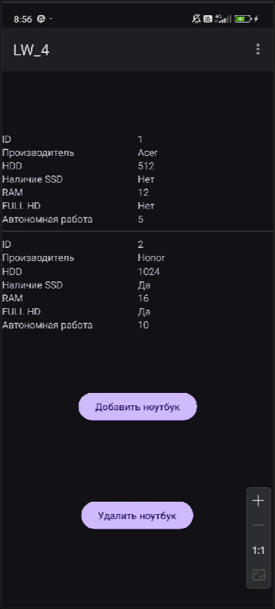
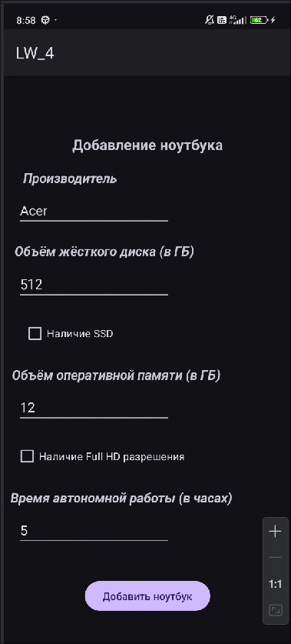
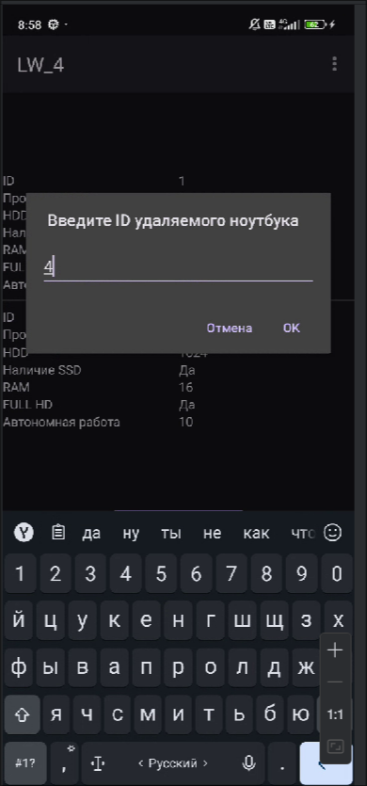

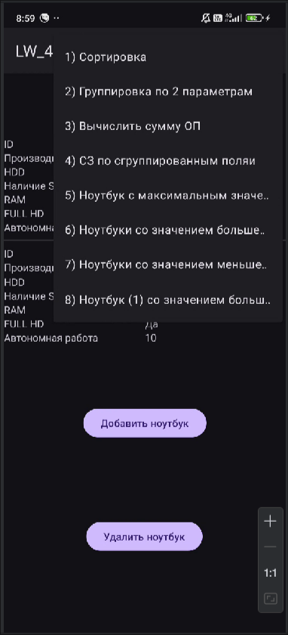
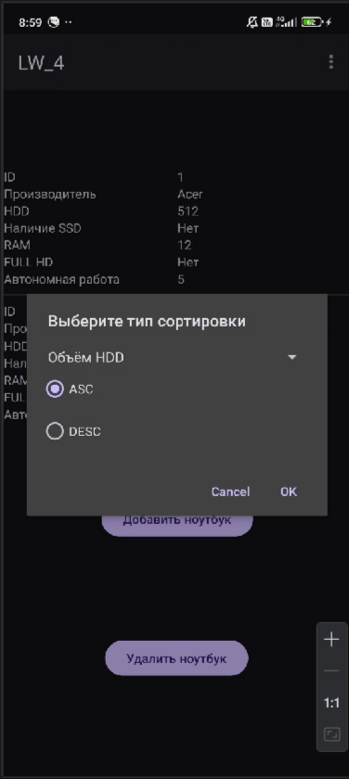
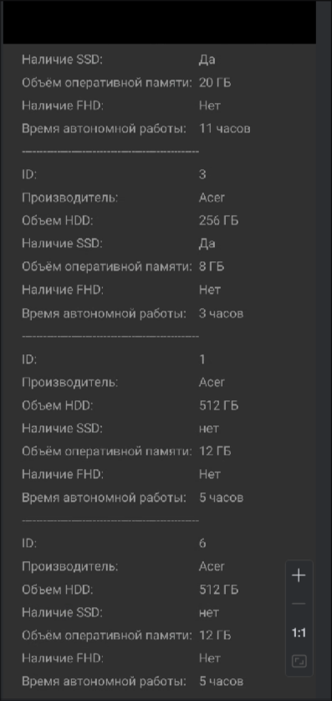

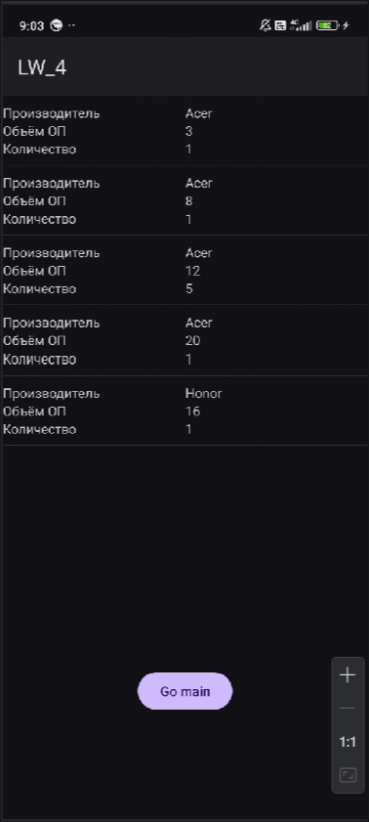
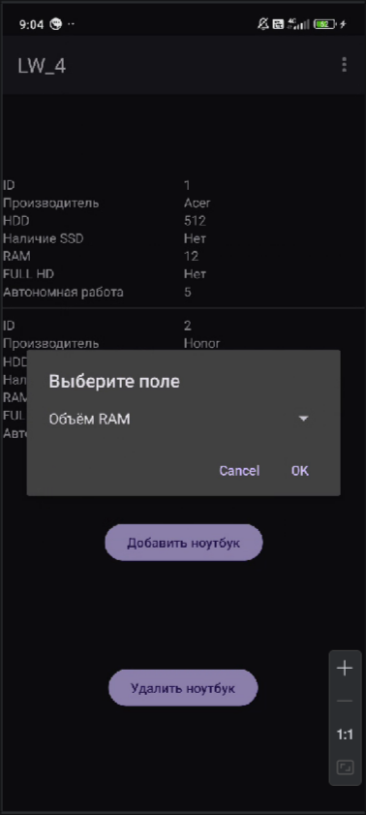
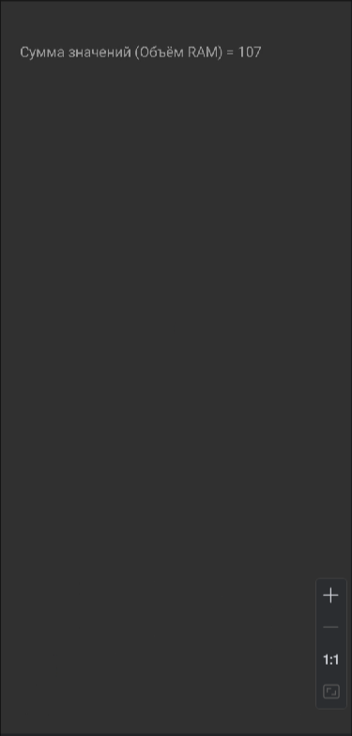

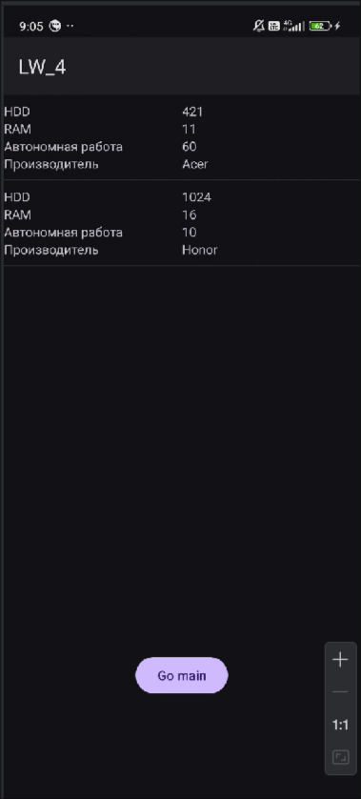
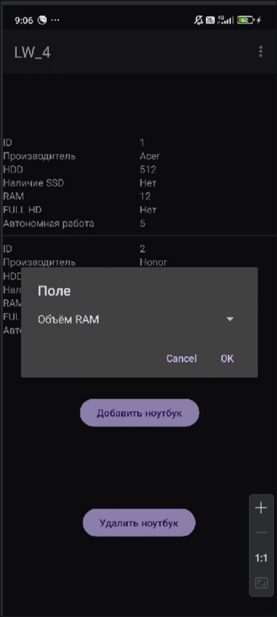

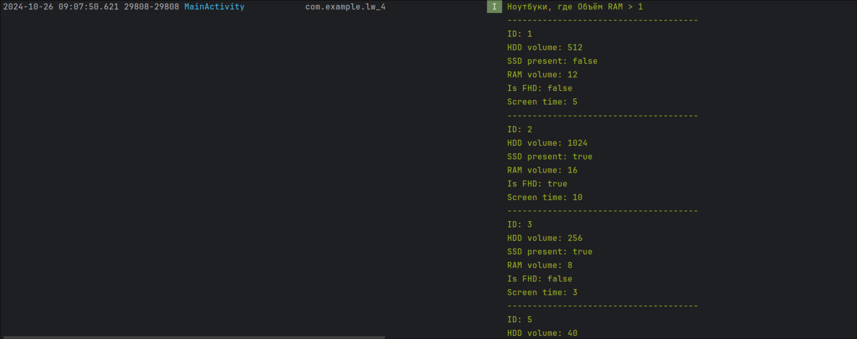
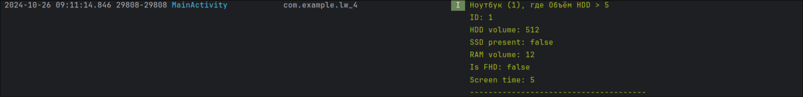
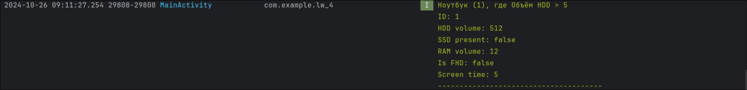
Вывод: в ходе лабораторной работы было разработано приложение, взаимодействующее с базой данных SQLite.

